Seal-borne sensors reveal fine-scale foraging ecology and evidence for topographically enhanced downstream submesoscale ocean variability at Marion island

by

Sean Evans (EVNSEA001)



Supervisors**:**

Marcel du Plessis­1, Mia Wege2, Isabelle Ansorge3, Andrew Lowther4, Nico de Bruyn2.

1[Department of Marine Sciences](https://www.researchgate.net/institution/University_of_Gothenburg/department/Department_of_Marine_Sciences), University of Gothenburg, Sweden; 2Department of Zoology & Entomology, University of Pretoria, South Africa; ­­3­Department of Oceanography, University of Cape Town, South Africa; 3Norwegian Polar Institute, Norway.

Dissertation presented for the Degree of

**Master of Science**

in the Department of Oceanography

University of Cape Town

March 2021

I know the meaning of plagiarism and declare that all the work in the document, save for that which is property acknowledged, is my own.

**Rough Outline**

Seal-borne sensors on subantarctic fur seals at Marion island: Investigating diving responses to upper ocean thermal structure and seasonal topographic influences on downstream submesoscale variability.

Seal-borne sensors reveal diving responses of a key Southern Ocean predator to thermal water column structure and seasonal topographic influences on downstream submesoscale variability

What I was going to do and why it could not be done with perhaps some images and data.

General diving behaviour using broken stick model. Dive summary data per season How do certain dive parameters change with diel phase?

A table showing columns of thermocline vs mixed and stable vs unstable (season may be a factor to consider here though). We know there will be changes with season and so we must remove that by making separate tables for winter and summer.

How does the foraging ecology vary with diel phase and is this related to the stability and vertical mixing?

We explored the possibility of using a state space model to define dive states where we do not necessarily know what the state represents e.g. short and shallow dives vs long and deep dives (with time) based on dive variables. However, this did not fit into the scope of this MSc and is only suitable for time series data.

Notwithstanding,Nevertheless,Nonetheless,In contrast,In spite of, Despite, Although,albeit,yet

# 

# Declaration of originality

I, Sean Evans, declare that this dissertation, which I hereby submit for the degree MSc (Ocean and Atmospheric Science) at the University of Cape Town, is my own work and has not previously been submitted by me for a degree at this or any other tertiary institution.

Signature:

Date

This thesis should be cited as: Evans S (2021) Seal-borne sensors reveal fine-scale foraging ecology and evidence for topographically enhanced downstream submesoscale ocean variability at Marion island. MSc Thesis, University of Cape Town.

.

# Summary

**Title:** Seal-borne sensors reveal fine-scale foraging ecology and evidence for topographically enhanced downstream submesoscale ocean variability at Marion island

**Student:** Sean Evans

**Supervisors:**

Dr Marcel du Plessis (University of Gothenburg, Sweden)

Dr Mia Wege (University of Pretoria)

Prof. J. Isabelle Ansorge (University of Cape Town)

Dr D. Andrew Lowther (Norwegian Polar Institute, Norway)

Prof. P.J. Nico de Bruyn (University of Pretoria)

**Degree:** MSc (Ocean & Atmospheric Science) Department: Oceanography, University of Cape Town

**Summary:** This thesis focuses on the influence of upper ocean structure and variability on Sub-Antarctic fur seal (*Arctocephalus tropicalis*) diving behaviour and what seal-borne loggers can tell us about the submesoscale ocean landscape around Marion Island

Animal-borne satellite relay data loggers have the potential to change the face of marine science in allowing the acquisition of large numbers of vertical profiles of ocean properties together with behavioural parameters in extremely inaccessible areas of the globe (Bester *et al.* 2011; Ryan and Bester 2008). The Prince Edward islands are an important habitat for seals because their location is within striking distance of oceanic fronts and eddies with high levels of biological production (Lutjeharms and Ansorge 2008; McQuaid and Froneman 2004). These top predators play a critical role in marine ecosystem function, structure and dynamics through trophic interactions and the abiotic factors that may be influencing them (Phillips and Harvey, 2009; Kirkman *et al.*, 2019). The complex interactions between the seals at-sea behaviour and the physics of the surrounding environment therefore has an influence on the larger oceanic setting of the islands (Ansorge and Lutjeharms 2000). With potential evidence of climate change effecting the Prince Edward Islands and surrounding environment (Ansorge *et al.* 2014; Asdar 2018; Boelhouwers *et al.* 2008; Smith 2002), greater understanding of seal foraging ecology may aid in the development of improved conservation management and policy.

Direct observations of feeding in subantarctic marine predators is especially challenging, but animal-borne data loggers allow us to dive into their world providing an opportunity for behavioral inference without having to directly observe prey capture and consumption.

Data loggers were deployed on *Arctocephalus tropicalis* seals at Marion Island from 2009-2015 to obtain dive profiles and physical ocean properties (e.g. temperature). Seals tended to forage directly to the west and east of Marion Island within the Antarctic Circumpolar Current, thereby allowing a case study of ocean dynamics within this region. A major aim of this research is to use the seals as ocean samplers in order to access the topographic influence of Marion Island on downstream submesoscale variability and vertical stratification. These upper ocean dynamics drive air-sea fluxes of carbon and heat, and understanding these processes is therefore critical for climate modelling and climate change predictions.

# Acknowledgements

My family and friends for supporting me.

The South African Department of Environmental Affairs for providing logistical support within the South African National Antarctic Programme (SANAP) and the Department of Science and Technology (administered through the National Research Foundation) for funding the Marion Island Marine Mammal Monitoring Programme. SANAP for funding my studies.

Thank you to all the past sealers who have made the incredible effort to deploy and retrieve the devices used to collect data for this thesis.

I’d like to thank my supervisors for their tireless efforts in keeping me on track and guiding me through the process of formulating this thesis. I have learned so much from you and look forward to working by your side in any future endeavours that may arise. Dr Marcel du Plessis, thank you for being so approachable, for pushing me and providing feedback even at the busiest of times. You have gone over and above for me so thank you. Dr Mia Wege, a fellow sealer and giving supervisor. You have gained all of my respect and gratitude and I look up to you not only as a scientist, but also as a role model.

Prof Nico de Bruyn for supporting my year on Marion Island and believing in my abilities as a MIMMP member, including the support shown for my trip to Sweden. You have also been extremely accommodating, especially during my trips to Pretoria.

Dr Andrew Lowther for sparking my interest in Southern Ocean work and welcoming me to Norway for a short, yet productive visit. Sebastiaan Swart and his team in Sweden, Gothenburg for providing constructive feedback. Fabien Roquet for taking some time to discuss ideas for my thesis and supplying helpful code for exploratory analysis.

Finally a special thank you to Prof. Isabelle Ansorge for always supporting my academics and supplying endless opportunities for me to further my career.

Add Sebastiaans team logo here. ROAM-VIS. POLAR gliders.

# Disclaimer

Chapters 2 and 3 of this thesis were prepared for publication as separate manuscripts. Consequently, I apologise to the reader for any repetition that he/she may be subjected to.

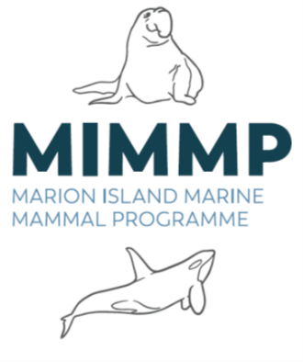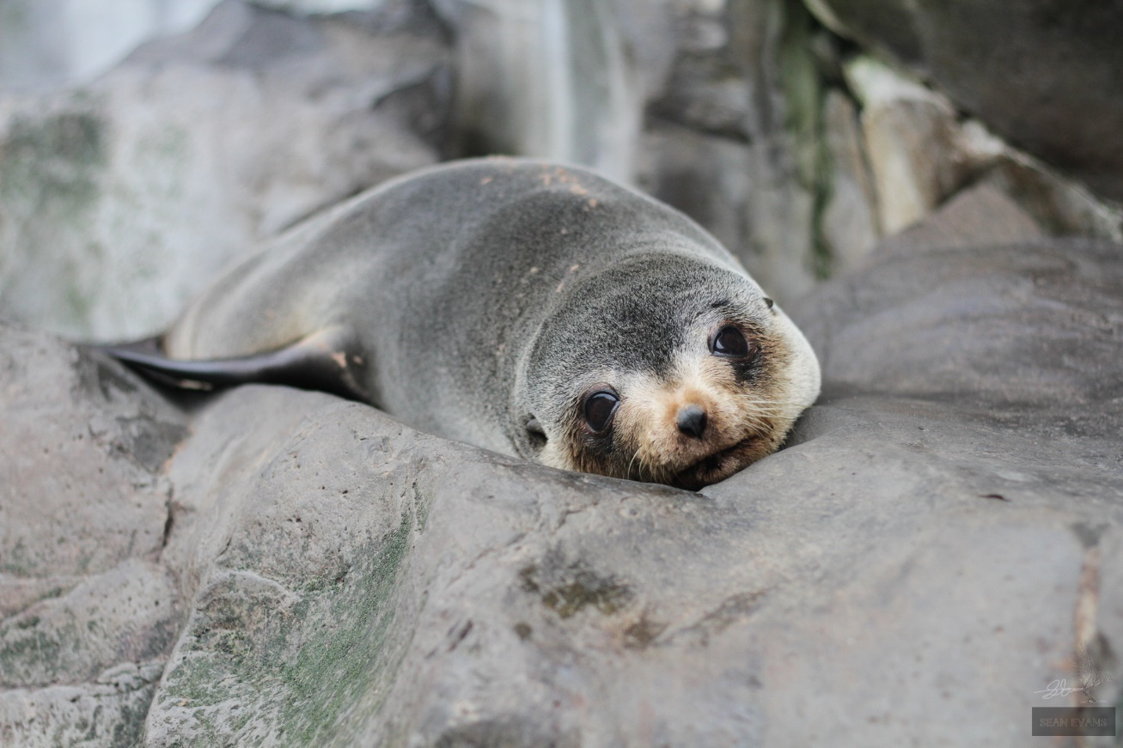

Figure : A mother Subantarctic fur seal

# Table of contents

Declaration of originality iii

Summary iv

Acknowledgements v

Disclaimer vi

Table of contents vii

List of figures ix

List of tables x

List of supplementary materials x

Chapter 1: General Introduction 1

Telemetry 1

Study area 1

SAFS abundance and distribution 2

Breeding biology and foraging ecology 2

hARS & vARS 3

Southern Ocean variability 3

Thesis structure, aims and objectives 6

Chapter 2: Influence of thermal water column structure on diving behaviour of Subantarctic fur seals at Marion Island: A scale-dependent approach using on-board data loggers. 10

Abstract 11

Introduction 12

Foraging ecology: A new era 12

Inferring foraging from movements (horizontal and vertical) 14

Southern Ocean and Prince Edward Islands 14

Fur seals at Marion Island 16

Aims: 19

Key Questions: 20

Materials and methods 22

Ethics statement 22

Study site, animal handling and instrumentation 22

Classifying divetypes 32

Thermal water column structure and vertical mixing 33

Generalized Additive Mixed-Effects Models (GAMMs) 35

Results 37

General and seasonal seal movements 37

Diel phase 38

Cluster analysis: What kind of dives do SAFS perform? 43

Ocean Stratification 44

Response of diving behaviour to ocean stratification 44

Discussion 44

Conclusion 45

Acknowledgements 45

Supporting information 45

Chapter 3: Topographic influence on downstream submesoscale variability: A case study at Marion Island using seal-borne data loggers 46

Abstract 46

Introduction 47

Southern Ocean and Prince Edward Islands 47

Topographic influences on submesoscale variability 48

Telemetry 48

Methods 50

Ethics statement 50

Study site, animal handling and instrumentation 50

Seal movements and behavior 51

Foraging metrics using broken stick model 52

Merging location and dive data. 54

Water column structure 54

Submesoscale ocean fronts 54

Results 54

Environmental variability 54

Foraging response to environmental variability? Horizontal and vertical area restricted search 55

Discussion 55

Conclusion 55

Acknowledgements 55

Supporting information 55

Chapter 4: General conclusion 56

Foraging and dive strategies 56

What can animal-borne data loggers tell us about the Marion ecosystem? 57

Environmental change and management 58

Future work 58

Synthesis 58

REFERENCES 59

# List of figures

Figure 1: A mother Subantarctic fur seal vi

Figure 2: The position of the Prince Edward Islands and the EEZ in the Southern Ocean, in relation to the CCAMLR statistical areas (Adapted from Lombard et al. 2007). 2

Figure 3: A tracked eddy for the period October 2004 to August 2005 using Sea Surface Height Anomaly (SSHA). The dimension of the eddy is given by the blue lines. The eddy travelled from the South-West Indian Ridge past the Prince Edward Islands after which it rapidly dissipated and was no longer in evidence as an anomaly in the sea height. The bottom topography is given in steps of 1 000 m. (Adapted from Ansorge & Lutjeharms 2005). 5

Figure 4: A healthy Subantarctic fur seal pup waiting for the return of its mother who is out foraging at sea. 10

Figure 5: The Prince Edward Archipelago’s location in relation to South Africa. A zoomed-in map shows Marion Island and Prince Edward Island approximately 20kms apart. The van der Boogard SAFS rookery is situated on the east side of the island, while on the west 22

Figure 6: A schematic of an MK9 and SPLASH tag (Adapted from Wildlife computers product feature sheets). 24

Figure 7: Schematic of a typical seal dive profile (black). The green segments within a dive are declared as 'foraging' segemnts according to the broken stick method, while the rest of the time the seal is predicted to be in ‘transit’ mode. Blue bars indicate the amount of time spent hunting within a foraging segment. The orange bars depict the distance over which a mean foraging depth is calculated within a foraging segment with associated error as the vertical distance between the two broken stick points. The post dive surface interval is the amount of time it takes for the seal to transit from when it surfaces above 4m after a dive until it dives again below 4m. 29

8 The longer the dive the higher the ht_rat 30

9 The deeper the dive the lower the ht_rat 30

10 ht_rat varies with diel phase and season (Is it significant?-use ANOVA maybe) 31

Figure 11: a) Summer and b) Winter maximum depth with diel phase (Change y axis limits). Colours correspond to the sample number of dives used to calculate boxplots for each hour based on local time of dives. 38

12 SubAntarctic fur seal bull holding his territory with a southern elephant seal in the background 46

13 Subantarctic fur seal sits in a rare sunny spot near Marion Island base 56

# List of tables

**No table of figures entries found.**

# List of supplementary materials

# Chapter 1: General Introduction

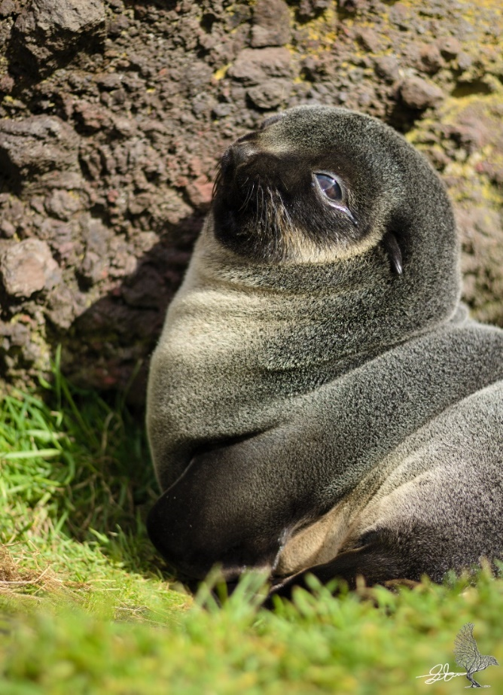

### Telemetry

These devices are autonomous tags that record the geographical location of the animal and inferred depth profile of temperature while the animal dives (Boehme *et al*. 2009).

### Study area

The Sub-Antarctic is a region in the ocean between Antarctic waters and the northern boundary of the Southern Ocean (Smith 2002). This region is home to Sub-Antarctic islands characterised by volcanic origin (<1 million y.a.) (Ansorge *et al.* 1999). Marion Island is one of a pair of islands known as the Prince Edward Archapelago home to three species of seals. Two species of fur seals, Antarctic fur-seals (AFS)(Arctocephalus gazella) and Sub-Antarctic fur seals (SAFS)(Arctocephalus tropicalus), share the beaches with large Southern Elephant seals (SES)(Mouringa leonina) (Chown and Froneman 2008).

Marion island is home to the largest sympatric population of Antarctic and Subantarctic fur seals in the world. This study focuses on the Subantarctic population of fur seals. There are two main rookeries

It is thought that the islands were first discovered in 1663, but the first landings were made in the 1800’s for fur seal skins and Elephant seal blubber in China (Cooper & Headland 1991). The seal industry declined from the 1850’s and the islands were annexed by the SA government in 1947 for strategic reasons (Crawford 1982, 1999). After South Africa lay claim to the islands they installed a meteorological station still used today for forecasting around Southern Africa and the Southern Ocean. This productive ecosystem has far-reaching influences (Chown *et al.* 20018). With the introduction of animal-borne sensors a continuous data record has been established using the MEOP programme launched in … for the purpose of ocean observation. MIMMP (Bester *et al.*, 2011)

On the 9 April 2013, the Prince Edward Islands were declared the first South African offshore MPA in its Exclusive Economic Zone (EEZ). This special MPA is part of a comprehensive conservation management regime for the biota and ecosystems on the islands and their oceanic surrounds (Lombard *et al.* 2017). It aims to contribute to the ongoing global initiatives towards protecting our deep oceans. The position of the islands (Marion and Prince Edward) in the southern Indian Ocean (*Figure 1*) also places them within the area managed by the Commission for the Conservation of Antarctic Marine Living Resources (CCAMLR) (Lombard *et al.* 2007).

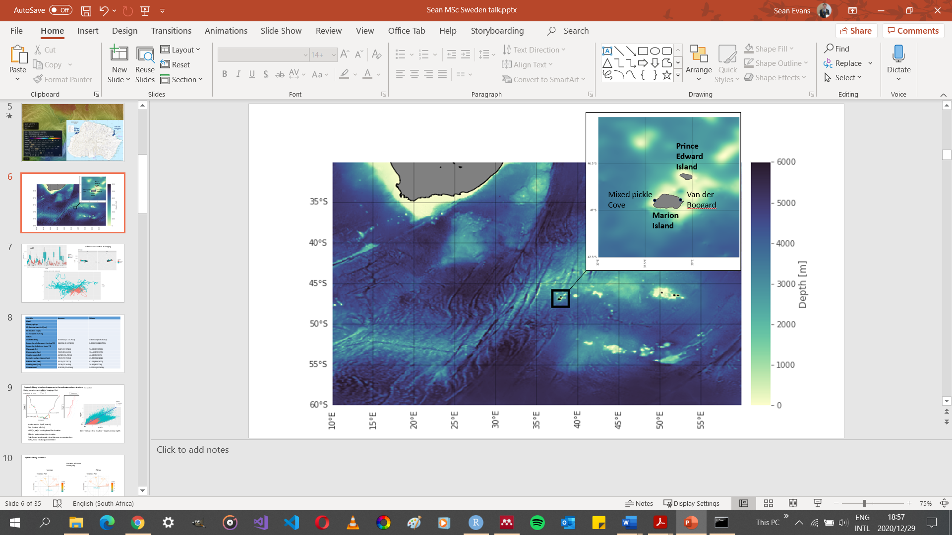

Figure : The position of the Prince Edward Islands and the EEZ in the Southern Ocean, in relation to the CCAMLR statistical areas (Adapted from Lombard et al. 2007).

### SAFS at Marion Island

Adult male, 88 kg and an adult female on average weighs 34 kg. Pups weigh about 4 kg at birth but grow rapidly and mass reaches an average peak at 200 days of age of 13 kg (females) and 15 kg (males).

Marion island history of seal slaughtering and long term effects on population. SAFS pup population is decreasing drastically. Not sure what the causes are, but here are the possible ones. AFS taking over, further foraging and effects on attendence patterns, intrinsic effects, preadation by killer whales, fishery effects…etc

History of thermal influence on fur seal distributions and diving behaviour (Kuhn *et al* 2010)

### hARS & vARS

In SES at Kerguelen Island, 77% of prey capture attempts (identified from the acceleration data) occurred in highly sinuous phases (“hunting”) as defined by Heerah *et al.* (2014) new approach.

What have previous studies of SAFS at Marion shown?

Kirkman *et al.*, 2016 used hARS methods to investigate suitable foraging areas for SAFS on neighboring Prince Edward Island and found that the most important factors were maximum during a foraging trip from the colony, longitude and distance from the Subantarctic Front created suitable habitat for foraging.

### Southern Ocean variability

**Mesoscale eddies and fronts:** The Prince Edward islands lie in the path of the Antarctic Circumpolar Current (AAC) driven by the strong and persistent westerly wind belt via Ekman transport (Nowlin and Klinck 1986). At these high latitudes there are major oceanic surface fronts associated with the ACC where sea surface temperature gradients are high (>2 °C per 100 km) (Bost *et al.* 2009; Lutjeharms *et al.* 1986). The archipelago sits between two major surface fronts characterising the Polar Frontal Zone (PFZ). These are the Sub-Antarctic Front (SAF) to the north and the Antarctic Polar Front (APF) to the south (Ansorge *et al.* 2014; McQuaid & Froneman 2004; Pakhomov & Chown 2003; Pakhomov & Froneman 1999a; Screen *et al.* 2009). Interactions between the atmosphere and the ocean influences the distribution of these fronts in the Sub-Antarctic with large effects on biology (Chown and Froneman 2008). Atmospheric oscillations such as the Southern Annular Mode (SAM), Sub-Antarctic Oscillation (SAO) and ENSO (El Nino Southern Oscillation) have been found to influence the position and timing of oceanic features, with potentially serious long-term consequences (Chown and Froneman 2008; Tosh *et al.* 2015).

Significant numbers of foraging seabirds and seals occupy these frontal systems (e.g. Abrams 1983; Abrams & Lutjeharms 1986; Chown & Gaston 1999; Nel *et al.* 2001; Pakhomov & McQuaid 1996). The physical processes occurring at these fronts are essential for such mobile predators (Barange *et al.* 1998) as they allow for ideal conditions for increased prey abundance (Pakhomov & Froneman 1999a) relative to surrounding waters. For example, warmer waters within the Antarctic Polar Front could correspond to the optimal conditions for myctophid prey of Southern Elephant Seals. (Bailleul *et al.* 2007). It has also been observed that the total phytoplankton biomass and phytoplankton production can be two to three times higher in these fronts than in the surrounding open waters of the Polar Frontal Zone (PFZ)(Pakhomov & Froneman 1999a). Although these systems are productive overall, the algal blooms are intermittent, creating sporadic presence of feeding predators from the islands (Llido *et al.* 2005).

Although ocean fronts are important feeding grounds for birds and seals, ocean mesoscale eddies have been found to express a similar ecological purpose. In the Southern Hemisphere, cyclonic eddies are clockwise and can be represented by a negative sea surface height anomaly (Ansorge and Lutjeharms 2003), while anticyclonic eddies rotate in the counter-clockwise direction (Ansorge and Lutjeharms 2003). Cyclonic eddies are associated with upwelling in the centre of the eddy and downwelling on the edges (Bakun 2006; Hogg 1973); while anticyclonic eddies are associated with downwelling occurring in the centre and upwelling on the edge (Bakun 2006; Hogg 1973). Moreover, the core of any eddy transports particles within it, while the outer part produces intense stirring of the ambient environment (Olson 1991). Bost *et al.* 2009 has shown that Southern Elephant Seals concentrate foraging activity principally inside or at the boundary of cyclonic eddies due to these physical processes.

The Prince Edward Islands benefits substantially from their position immediately downstream of an eddy corridor (Ansorge *et al.* 2014). When the ACC passes over a topographic feature known as the South West Indian Ridge (SWIR), to conserve potential vorticity, relative vorticity must change (Hogg 1973; Moore *et al.* 1999a). This may result in the generation of mesoscale eddies that are transported towards the islands (*Figure 2*) mostly by the ACC (Ansorge and Lutjeharms 2002; Ansorge and Lutjeharms 2005; Ansorge *et al.* 1999). Anticyclonic eddies are common on the plateau between Marion and Prince Edward (Perissinotto and Rae 1990). These are unlikely formed by an island wake vortex shedding process (Perissinotto and Rae 1990). Instead, Perissinotto and Rae (1990) states that they “appear to have some characteristics that are consistent with Taylor column phenomena”. Ansorge *et al.* (1999) suggested that within the downstream wake of the islands, a warm-cored eddy may have been generated due to baroclinic instabilities within the flow pattern of the SAF (Ansorge *et al.* 1999).

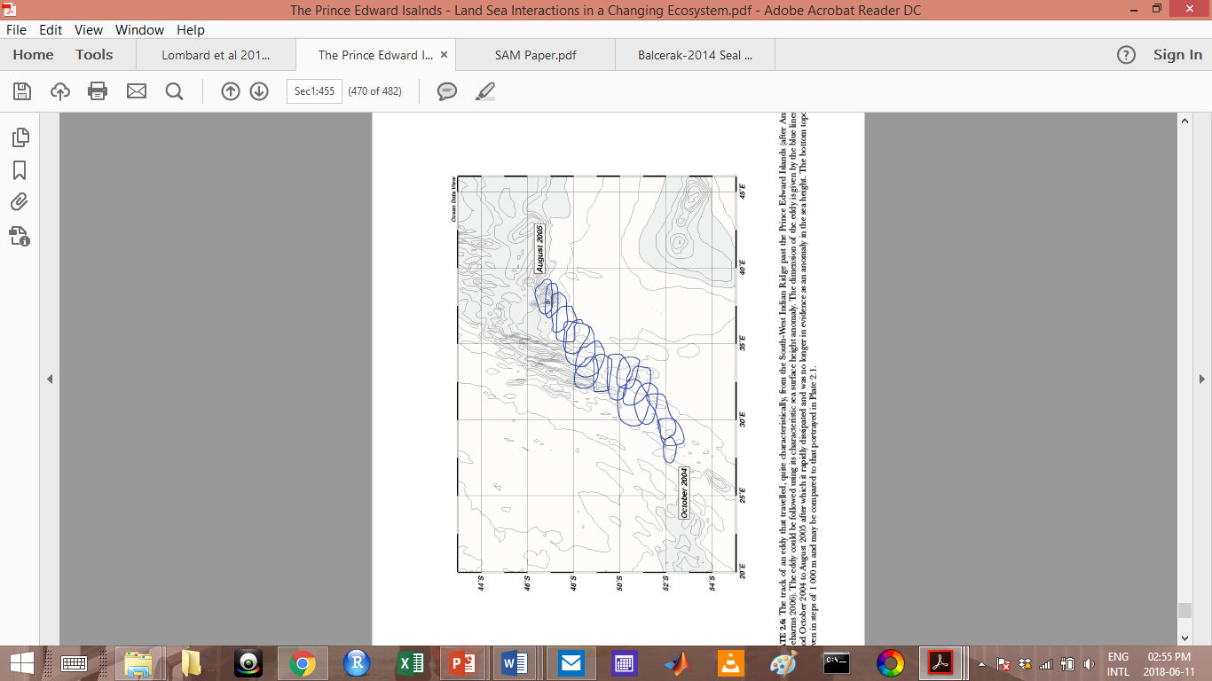

Figure : A tracked eddy for the period October 2004 to August 2005 using Sea Surface Height Anomaly (SSHA). The dimension of the eddy is given by the blue lines. The eddy travelled from the South-West Indian Ridge past the Prince Edward Islands after which it rapidly dissipated and was no longer in evidence as an anomaly in the sea height. The bottom topography is given in steps of 1 000 m. (Adapted from Ansorge & Lutjeharms 2005).

Tosh *et al.* (2015) showed that juvenile SES use warm-cored eddies that where generated north of the SAF, suggesting that these eddies may play a vital role in transporting biology across fronts. Eddies are also commonly generated at frontal structures, forming the basis of complex food webs (Pakhomov *et al.* 1994; Nel *et al.* 2001).

This enhanced mesoscale variability around the islands could be increasing local primary productivity within the PFZ (Ansorge *et al.* 1999) effecting the community composition of zooplankton and the distribution of food to Marion’s top pelagic predators (Pakhomov & Froneman 1999a; Pakhomov & Chown 2003). Thus, the dynamics of ocean surface fronts and mesoscale eddies in this part of the Southern Ocean are a key component in understanding the ecosystems of the islands (McQuaid & Froneman 2004).

Recent advances in technology has allowed for submesoscale ocean filaments to be resolved.

### Thesis structure, aims and objectives

Studies relating foraging behaviour to the environmental conditions experienced by the study animal using only the data from a device attached to this animal are limiting. This is because animals have a device size threshold before the device becomes too large and begins to influence behaviour and affect study results (Kingdom and Africa, 2011). Another contribution to limitations include the lack of environmental information beyond that experienced by the animal (Lowther, Lydersen and Kovacs, 2015), thus disregarding certain alternative options that animals may have when foraging and opening up the potential for bias, hampering a complete understanding of the animal’s foraging ecology.

In the initial stages of this MSc, the study focussed on conductivity-temperature-depth (CTD) devices attached to southern elephant seals (SES) at Marion Island that were going to be used to create environmental context for fur seal foraging behaviour. This is because southern elephant seals can carry relatively heavy and complex devices with no influence on survival or behaviour (Field et al., 2012), while the device size threshold of fur seals is much smaller, limiting the environmental covariates that can be derived for analysis. The main objective was to determine mixed layer depths in the areas of fur seal foraging trips using density calculated from the CTD data. We would then investigate whether fur seals increase foraging effort near the MLD.

Due to the interannual and seasonal variability in Southern Ocean conditions as well as spatial ocean variability from meso- to submesoscales in this region, overlap in data needs to be extensive for an effective foraging study like this, especially when the scales of fur seal foraging is poorly understood. With insufficient spatial and temporal overlap between SES and fur seal location estimates, environmental data from CTDs became irrelevant for the objectives in mind. Despite one of the elephant seals acting as a biological mooring by diving consistently within a small space to the north of the island, synchronous fur seal data remained to be seen and the idea was abandoned.

After revisiting the major themes of the study, newly revised methods have led to the inference of mixed layer depth based purely on temperature profiles without the need for density calculations. We now focus on what temperature-depth measurements collected by seal-borne devices can tell us about diving behaviour in relation to on board temperature readings. We have also investigated what information may be ascertained about the immediate environmental landscape these seals inhibit and whether seal behaviour is modulated by this oceanographic setting.

Chapter 2:

To understand whether submescale fronts modulate foraging behaviour we first need to understand the foraging behaviour. This is the aims of chapter 2, which sets up the knowledge base for the following chapter. All references are included in a single list at the end of the thesis.

Wege *et al.*, 2019 suggests that environmental conditions such as sea surface temperature and do not influence the distribution of preferred foraging habitats in Marion fur seals at the ~100km horizontal scale.

Can reference her PhD and MSc

Although studies have investigated general diving and searching behavior in relation to ocean features at the >20km scale using telemetry, no studies have considered the investigation of contemporary on-board temperature records.

Few studies at Marion Island have focused on SAFS diving and foraging behavior at fine scales (meters). Previous studies (De Bruyn *et al.*, 2009; Wege *et al.*, 2019) have concentrated on specific domains of scale and ignored others. This study aims to fill the range gap, by considering small scale foraging behavior and potentially associated environmental drivers.

Given central-place foraging breeders are spatio-temporally restricted they are more likely to increase foraging effort than foraging trip duration and distance (Costa 2008) in response to change. With a changing climate it is vital that we understand drivers of foraging effort.

Foraging decisions of seals using the information collected about environmental cues during the descent phase of a dive are complex and are constrained by physiological limitations on diving depth and duration (Viviant *et al.*, 2016). There are several indices that can be derived to investigate diving and foraging behavior of SO marine predators (Roncon *et al.*, 2018). This study aims to account for multiple available inferences about foraging that one can derive from telemetry, including hARS, by grouping dives into two main divetypes. This will simplify large amounts of information about diving behavior for analysis of downcast cues in temperature that may be influencing decision making within a dive.

In chapter 4, I summarise Chapter 2&3 and suggest a way forward for marine top predator foraging ecology and Southern Ocean submesoscale variability.

I wrote chapters 2 & 3 as an independent manuscripts for publication. As such, some repetition was unavoidable, especially within the ‘methods’ sections.

I provide a conceptual framework of this thesis in figure …



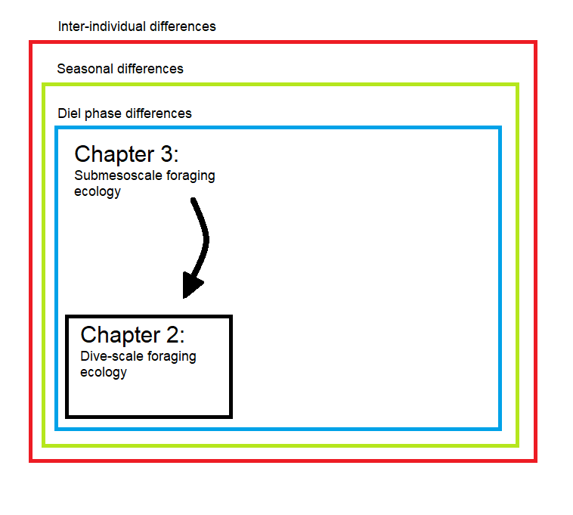

# Chapter 2: Influence of thermal water column structure on diving behaviour of Subantarctic fur seals at Marion Island: A scale-dependent approach using on-board data loggers.

Sean Evans, Mia Wege, Marcel du Plessis, Nico de Bruyn, Isabelle Ansorge

Disclaimer: This chapter is prepared for publication in (what journal?).

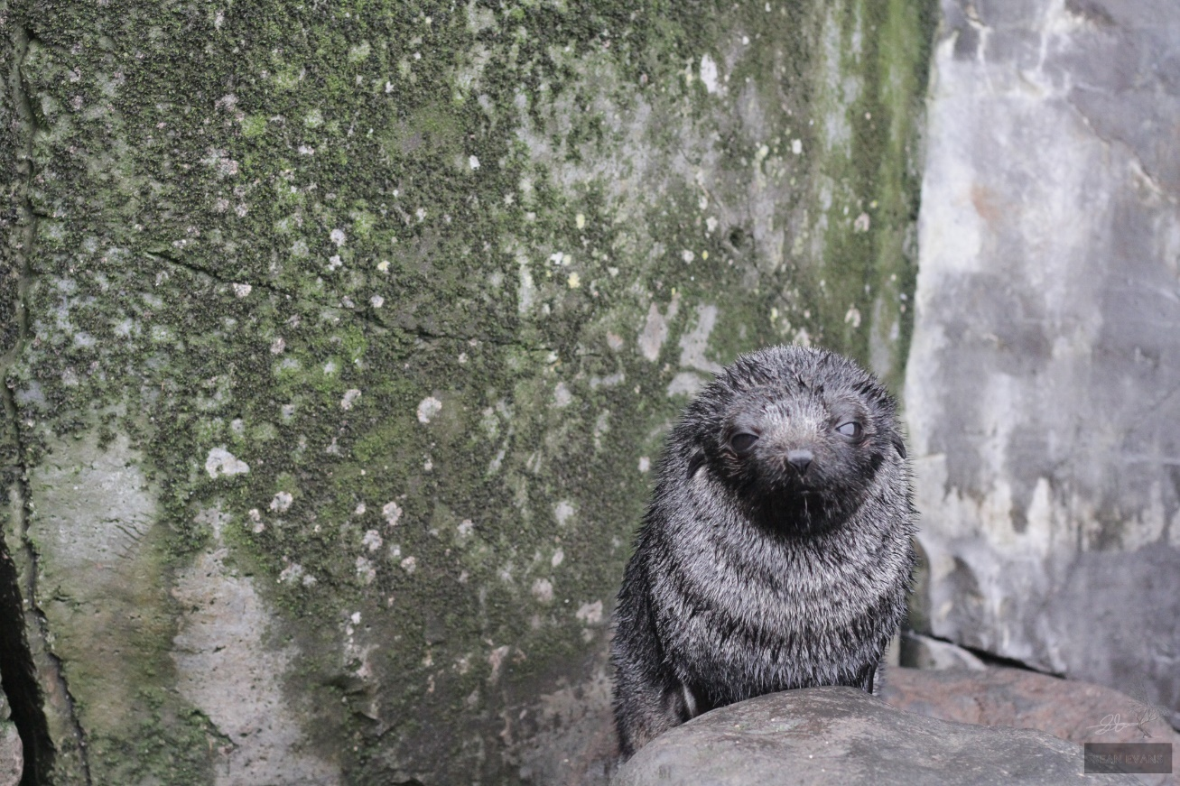

Figure : A healthy Subantarctic fur seal pup waiting for the return of its mother who is out foraging at sea.

## Abstract

Observing the foraging behaviour of fur seals within the Southern Ocean has formerly been difficult due to their geographic isolation and marine habits. Over the past two decades, important behavioural information of far-ranging fur seals at sea has been gained through effective bio-loggers. Sub-Antarctic Marion Island provides a unique opportunity to study the effects of environmental variability on the foraging ecology of these key predators (*Arctocephalus tropicalis*). *In situ* environmental data collected by animal-borne telemetry devices fitted to adult female *A. tropicalis* adult females were used here to investigate diving behaviour and foraging effort. A broken stick model along with various other methods were used to calculate foraging effort indices. The most appropriate variables were then drawn for cluster analysis to distinguish two main dive types. Analysis of individual seals movements with depth, associated with novel insights of fine scale vertical mixing in the water column, allowed investigation of how movement decisions may be influenced by the small scale (<1m) variations in vertical structure of the water column. Furthermore, the study aimed to investigate how possible decision-making environmental cues could explain broader patterns in fur seal foraging behaviour around Marion Island. By improving our understanding of what drives the foraging behaviour of fur seals, we can more accurately predict how regional and global change may affect these populations in the future. With the proposed shifting of fronts by climate change, fur seal foraging success may be impacted, with potential consequences for breeding success.

**Key words:** Arctocephalus, Subantarctic fur seal, Marion Island, submesoscale, temperature .

## Introduction

Causal relationship

While ‘foraging’ is the act of searching for food, ‘hunting’ is defined as the act of chasing down prey for consumption. Therefore, hunting will be used as the verb for segments within a dive where the seal is actively changing its vertical movements within the water column for prey consumption.

### Foraging ecology: A new era

Understanding how abiotic factors drive the geographic distribution of blooms at various scales and how higher trophic levels respond could unravel clues for future biogeography of marine top predators. Information relating to such bottom-up control is fundamental for the robustness and effectiveness of conservation management in the Southern Ocean (Leathwick, Elith and Hastie, 2006; Biuw *et al.*, 2007; Pirotta *et al.*, 2014), especially in the context of climate change and the consequent changes in ocean circulation and biogeochemistry.

Foraging success is a basic determinant of all life history traits, directly influencing survival, reproductive success and population growth (Stearns, 2000; Stevick *et al*.,2002; Stephens *et al*.,1986). Knowing how, when and where animals acquire and maximize resources is therefore key in predicting animal population trends. Collecting direct observations of prey consumption by subantarctic marine top predators remains difficult due to human limitations in accessing the isolated regions which these animals inhibit (Harcourt *et al.*, 2019).

The impediments related to the objective difficulties of exploring remote subsurface ocean habitats and our inability to avoid the fissures between inferences and true representations of foraging behavior without direct observation has been a major source of the challenges faced in foraging studies of marine top predators (Heerah *et al.*, 2014). Marine mammal foraging ecology can be investigated using stomach samples, scats, blubber fatty acids, stable isotopes (whiskers), and genetic methods (Arnould, Boyd and Speakman, 1996; Arce *et al.*, 2019). Biotelemetry and biologging has been developed.

Despite the lack of quantitative information of foraging success, foraging effort can be inferred from movement data (biotelemetry and biologging) and provides a temporal-spatial distribution of energy expenditure (Arnould *et al.*, 1996; Arce *et al.*, 2019) without having to directly observe prey capture and consumption (Pirotta *et al.*, 2014). Biotelemetry has allowed for near real time acquisition of seal tracking and diving records from devices deployed on marine predators relayed via satellites without the need to physically access the tag. This is useful for when seal recapture for device retrieval is difficult or impossible. However, such devices on diving animals, especially those with short surface times between dives, can pose a limitation of data quantity that can be transmitted to available satellites (Bestley *et al.*, 2020). The time-depth profiles retrieved are usually summarized using a broken stick algorithm before being transmitted (Fedak, Lovell and Grant, 2001), reducing the resolution of data with the potential to hamper identification of fine-scale diving and foraging behaviour (Heerah *et al.*, 2014). Retrieving time-depth recording archival tags (Biologging) directly from the animal allows acquisition of higher resolution data not only recording behavioural parameters, but simultaneously recording *in situ* physical oceanography of surrounding waters. According to the Marine Mammals Exploring the Oceans Pole to Pole (MEOP) most *in situ* oceanographic profiles measured south of 60◦S come from bio-loggers (Fedak, 2013) (Treasure et al., 2017). Notwithstanding the benefits of these high-resolution data, the overwhelming risk of losing tags through failed retrieval efforts has driven the production of a new generation of devices where advantages of both device types are adopted (Heerah *et al.*, 2019).

Although high resolution accelerometers can be used to calculate the number of prey capture attempts (PrCA) of a seal, Heerah *et al.*, 2015 showed that most PrCA events can be captured just as well using TDRs.

Studies have linked diving behaviour to temperature before (Boyd and Arnbom, 1991). Elephant seals are known to exploit food sources at the discontinuity between vertically stratified water masses.

A substantial improvement in the way ecologists could collect data over the past few decades has changed the way we understand marine top predator movement behavior. Enhanced data accessibility, data storage, data management, analytical techniques, and technology has driven a new era of ecological biology. Modern use of cameras, stomach and oesophageal temperature sensors, and accelerometers capturing head or jaw movements can be used to specifically target scientific questions relating directly to foraging ecology. Although these modern approaches provide extremely detailed information, battery life puts limits on the length of time series data.

Less location error is associated with devices fitted to animals with relatively short duration dives and extended surface periods (e.g. fur seals) (Costa *et al.*, 2010).

### Inferring foraging from movements (horizontal and vertical)

Read Heerah et al 2014, 2015,2019

Although high residence times are likely indicative of important foraging areas over broad spatiotemporal scales (>100km), limitations to the accuracy of hARS indices in estimating foraging success become apparent at smaller scales (Patterson *et al.*, 2016). In the presence of accompanying vertical, high resolution data, more accurate inference of foraging success can be made (Heerah *et al.*, 2014; Arthur *et al.*, 2016). This information may aid in determining potential drivers of foraging effort and potential threats to foraging in the future (Hussey et al 2015: Aquatic animal telemetry: A panoramic window into the underwater world). Investigating the drivers of foraging effort in marine systems is especially challenging, making the opportunity for such studies unique and rare (Arce *et al.*, 2019).

Using only horizontal location data to identify drivers of marine mammal distributions in space ignores a fundamental dimension of such air-breathing deep-diving animals (Photopoulou *et al.*, 2020). The vertical distribution of predators relies on the vertical distribution of prey within the water column.

### Southern Ocean and Prince Edward Islands

Marine environmental resources are generally patchy, heterogeneous, and dynamic in nature (Stevick *et al.*, 2002, Pinaud and Weimerskirch, 2005). The Southern Ocean is mostly low in nutrients with ephemeral spring phytoplankton blooms contributing substantially to Southern Ocean productivity (Smetacek and Nicol, 2005). Blooms predictably tend to occur on island shelves and along surface ocean fronts within the Antarctic Circumpolar Current (ACC) when nutrients become available through interactions between the sea floor, water mass properties and ocean currents (Moore and Abbott, 2000). However, in the open ocean high biomass can also be associated with relatively unpredictable ocean variability at a multitude of scales (Stevick *et al.*, 2002 look for other studies). Thus, we can expect that marine predators should be able to respond to the hierarchical patch distribution at several spatial scales

The Prince Edward region is a breeding and feeding ground for marine mammals and seabirds (Lutjeharms and Ansorge 2008; McQuaid and Froneman 2004) and is of particular importance to scientists interested in pristine systems and associated surrounding ocean dynamics (Ansorge *et al.* 2014; Lutjeharms and Ansorge 2008). Marion Island is the larger (270 km2) of the pair of islands, with Prince Edward (45 km2) situated 19 km’s northeast of Marion (Lutjeharms and Ansorge 2008). These islands are young and volcanic (shield volcanoes) in origin (< 1 mil yrs old) and are situated in the roaring forties and north of the furious fifties (Ansorge *et al.* 1999). They lie in the path of the AAC (Lutjeharms and Valentine 1984; Lutjeharms 1985) within the Polar Frontal Zone (PFZ) with the Sub-Antarctic Front (SAF) to the north and the Antarctic Polar Front (APF) to the south (Ansorge *et al.* 2014; Emery 1977; Hofmann 1985; McQuaid & Froneman 2004; Pakhomov & Chown 2003; Pakhomov & Froneman 1999a; Screen *et al.* 2009). These fronts bound the ACC and are characterised by strong temperature, salinity and density gradients (Bost *et al.* 2009).

In addition to major frontal systems, the islands experience eastward propagating mesoscale turbulence in the form of eddies (Ansorge *et al.* 1999; Ansorge and Lutjeharms 2005).

Both Southern Ocean surface fronts and mesoscale eddies in this region are typically associated with high productivity promoted by the physical processess that are associated with them (Anorge *et al.* 1999; Griffiths *et al.* 1982; Lutjeharms *et al.* 1985; Moore *et al.* 1999b; Olson 1991; Pakhomov and McQuaid 1996; Pakhomov *et al.* 1994). Within these features phytoplankton can make use of nutrient-rich deep water that is driven into the euphotic zone via vertical mixing (Moore *et al.* 1999b; Olson 1991; Pakhomov and McQuaid 1996). Once vertical mixing has reduced phytoplankton and coinciding high nutrient levels are trapped within the light zone allowing for photosynthesis to take place. The reduction in competition for nutrients and synchronized water column stability increases the phytoplankton biomass until resources are completely depleted or mixing restarts, thus supplying higher trophic levels and eventually top mobile predators with a temporary food source in a scarce ocean (Bakun 2006; Bost *et al.* 2009; Cotté *et al.* 2015; Tosh *et al.* 2015). Foraging seals from subantarctic islands appear to utilize these exceptionally productive mesoscale eddies and surface fronts (Bost *et al.* 2009; Cotté *et al.* 2015; Tosh *et al.* 2012; Tosh *et al.* 2015). Foraging success (not effort) of these seals can be quantified using diving behaviour (e.g. Biuw *et al* . 2003, Thums *et al* . 2008) which is vital in the efforts to link animal movements, individual success and population dynamics (e.g. Weimerskirch *et al.* 2012).

Multiple scales to be considered, each treated separately in previous studies at marion. SAFS – Nico bathymetry and Mia larger scale analysis. Nobody has looked at possible cues within each dive and whether this may be influencing broader scale foraging behaviour (West East approach). Maybe I should make chapter 2 about West-East comparison and then look at the finer scale to see whether seals are changing their diving behaviour in relation to mixing?

Many species at Marion Island show marked seasonal differences in distributions, foraging trip length and distance and diving behavior supported by other studies (De Bruyn *et al.*, 2009; Wege, 2013; Kirkman *et al.*, 2016; M Wege *et al.*, 2016; M Wege, 2017; Wege *et al.*, 2019).

strong directional tendency in their movement (Reisinger, Raymond, *et al.*, 2018)

Importance of Temperature (including metabolic) and mixed layer depth (Kuhn et al.)

### Fur seals at Marion Island

There are three seal species inhabiting this archipelago. These are the Sub-Antarctic Fur Seals (SAFS) (Arctocephalus tropicalis), Antarctic Fur Seals (AFS) (Arctocephalus gazella) and Southern Elephant Seals (SES)(Mirounga leonina) (Ryan and Bester 2008). Largest sympatric population of Antarctic and subantarctic fur seals (Hofmeyr *et al.*, 2006; Mia Wege *et al.*, 2016; Reisinger, Landman, *et al.*, 2018).

History of SAFS at Marion.

As Pinnipedia (a.k.a Seals), Subantarctic fur seals (Arctocephalus tropicalis) are members of the superfamily Otariidae, eared seals. Otariid mothers must feed during the lactation interval, an evolutionary pattern related to metabolic rates, energy and oxygen storage capacity and body size, imposing limits on for example foraging trip duration. This breeding pattern is expensive but optimises provisioning of pups. A major downfall to this evolutionary strategy is the need for favourable foraging conditions over the lactation interval when feeding ranges become limited by pup fasting ability. *(Good discussion point for later).*

As central place foragers SAFS mothers perform short foraging trips in early summer just after giving birth during which pups fast until the mother returns with milk to suckle. These short trips maximize nutrient and energy investment in the pup. The foraging trips slowly become longer as the pups grow and their ability to store more energy, thus fasting for longer increases. Eventually after about 8 months the pups are weaned and no longer depend on their mother for food. Nor do weaners depend on mothers for development seen in some other mammals thereby making them completely independent. The mothers are free to forage away from the island until next breeding season when she may give birth again and the process restarts.

What do they feed on? What is their relationship with gazellas? Pup population trends…

Vertically migrating myctophid fish make up … of subantarctic fur seals diet at Marion Island (). Although the diets of the sympatric populations are similar, small but significant differences in the relative proportions of prey are evident (Reisinger, Landman, *et al.*, 2018) suggesting niche partitioning between the species. The lack of significant long-term dietary changes of Subantarctic fur seals, suggests that diet is not a key component contributing to the substantial decrease in pup population size. However, dietary studies lack information such as changes in foraging effort or prey availability, which may prove important for long term effects on populations. First we have to understand fine scale foraging ecology.

In the Southern Ocean oceanic zone, myctophids dominate with highly correlated distributions with oceanographic variables (Koubbi *et al.*, 2011). These prey species of subantarctic fur seals at Marion generally undertake vertical migration into the shallower parts of the water column every night (Klages and Bester, 1998) making seals likely to gain an energetic advantage by hunting at night when dives don’t have to be as deep to find prey (Croxall *et al.*, 1985).

How do Marion Island fur seals (diving) compare to other islands (Mia MSc).

Colony-specific and seasonally specific foraging trip lengths. Contrary to findings from De Bruyn *et al.*, 2009, ….. found that overnight foraging trips occur during summer in high density SAFS (but interestingly not low density SAFS) (Mia Wege, 2017), aligning with findings for populations at similar latitudes. (Amsterdam, Iles Crozet, Macquarie Island)( Robinson et al. 2002, Beauplet et al. 2004). Longitude and latitude, current speeds, sea surface height anomalies and bathymetry likely influence oceanographic conditions explaining preferred foraging habitats of SAFS at Marion (De Bruyn *et al.*, 2009; Wege *et al.*, 2019). However, Mia showed that suitability of habitats is not necessarily the driving factor for foraging …

Overlap with AFS and other seals from other islands. Site fidelity (overlap within populations – inter-individual) Inter-seasonal and inter-annual.

Very basic studies done on diving behaviour, despite all the work that has been done on fur seals at Marion. Little is known about fine scale foraging behaviour.

Larger scale stuff: Fur seal diving (SAFS and AFS) behaviour is influenced by large ocean fronts like the SAF (Beauplet *et al.*, 2004; Arthur *et al.*, 2016; Georges *et al.*, 2018).

Tropicalis diving and foraging behaviour (will mostly be horizontal ARS). Marine predators target edges of eddies and large ocean fronts. SAFS decline in pup population? Why? Lets look at Fine scale oceanographic influences on foraging behaviour and see if this might have an effect on.

Site fidelity and preferred foraging areas.

History of thermal influence on fur seal distributions and diving behaviour (Kuhn *et al* 2010)

Read (Bester *et al.*, 2012)

### Aims:

Since the early twentieth century, seals at Marion have been able to capture the ocean properties and behavioural parameters in otherwise inaccessible areas, thus assisting scientists in their efforts for physical oceanographic data collection and the assessment of seal foraging behaviour (Bester *et al.* 2011; Ryan and Bester 2008; Pistorius *et al.* 2011; Tosh *et al.* 2015). However, many studies on foraging behaviour of marine top predators typically use horizontal ARS methods and ignore the vertical component.

Our methods are not solely based on one foraging effort criteria. Rather we take several available methods and choose the resultant variables which describe the most variance using a PCA. From these variables we perform a cluster analysis to access the whether distinct groups of dives are formed. Finally, we carry out an analysis of diving response to abiotic conditions recorded from the tag itself. An indication of the immediate environment on diving behaviour, instead of the surrounding environment.

In future studies it may be best to incorporate more data that is available for the surrounding waters at high resolution to be able to make a clear comparison of the choice the seal has in its movements.

This is therefore a dive-wise approach to see whether the seals behaviour changes based on the conditions experienced in a given dive.

We hypothesise that the fur seals at Marion Island are targeting startified water columns and are focussing foraging effort around the depth of the thermocline. We would expect seals to be foraging more in stratified water masses (where Nt is high and a thermocline is present) as recent mixing has probably taken place bringing up nutrients and trapping photosynthetic organisms in the euphotic zone with cascading effects on higher trophic levels.

The current issue scientists face is the overload of data and the need for simplifying and extracting important information from a haze of information.

The main aim of this study is to develop a greater understanding of the vertical structure of surrounding Marion waters and how this may directly effect seal foraging behaviour at fine scales (per dive). By collating this data, I hope to investigate its value, not only in an ecological sense, but in an oceanographic sense too.

We further evaluated the influence of the seasonal cycle on those environmental factors (Nt and mean_Temp) using Kruskal-Wallis ANOVA. Like in Nico and Mia papers.

Specific objectives are to:

* Determine distinct diving behaviours of Sub-Antarctic fur seals using data collected from TDR loggers attached to the seals
* Determine whether these dive types are influenced by the thermal structure of the water column (Nt, mean_Temp and mixed vs stratified).
* Describe where subantarctic fur seals forage within the water column and whether this is related to the thermocline.

We hypothesise that SAFS at Marion Island are targeting mixed layer depths (thermoclines due to dominating thermal change component of density) and their diving behaviour is significantly influenced by thermal water column structure.

Do subsurface ocean characteristics influence seal behaviour?

According to several diving behaviour indices as a proxy for foraging effort to ask:

### Key Questions:

1. What are the general maternal Subantarctic fur seal diving and foraging patterns? (Interannual variation, seasonal variation, foraging trip variation, Diel phase variation)
2. What kind of dives do Subantarctic Fur seals (SAFS) perform at Marion Island within a season? How does this vary with season, year and diel phase? Can’t compare season as we treat seasons differently during cluster analysis. Everything before that we can compare.
3. Does the stability (absolute(Nt)), the structure (i.e. stratified vs mixed), or/and the mean temperature of the water column experienced by a seal in a given dive influence the type of dive performed by that seal?
4. Do the seals target the mixed layer depth? If this is not true then does the general dive behaviour change (gam model)? Compare foraging depth to mixed layer depth when mixed layer is observed.? How close is the mean difference to zero?

## Materials and methods

Summary data has been reported as mean ± SE, unless otherwise noted. To address the main questions in this study the following methodology was carried out.

### Ethics statement

All animal handling and experimentation were undertaken with approved ethics clearance from the Animal Use and Care Committee (AUCC) of the Faculty of Natural and Agricultural Sciences, University of Pretoria, South Africa, under AUCC 040827-023.

### Study site, animal handling and instrumentation



Figure : The Prince Edward Archipelago’s location in relation to South Africa. A zoomed-in map shows Marion Island and Prince Edward Island approximately 20kms apart. The van der Boogard SAFS rookery is situated on the east side of the island, while on the west

It was only in the twentieth century that scientists began to realize that valuable data could be obtained from remote areas frequented by animals (Treasure *et al.*, 2017). This led to the development of animal-borne data loggers. At Marion Island (46˚ 54’ S, 37˚ 45’ E), some subantarctic fur seals (SAFS) and Antarctic fur seals (AFS) carry telemetry devices. Although Subantarctic fur seals haul out around the entire coast of Marion Island (Hofmeyr *et al.*, 2006), tags used in this study (SPLASH & MK-9|PTT) (Figure 6) were deployed at and recovered from two SAFS rookeries, van der Boogard beach and Mixed Pickle cove (Figure 5), by Marion overwintering sealers from 2009 to 2015 for the purposes of tracking horizontal and vertical movements along with temperature data. This forms part of the objectives of the Marion Island Marine Mammal Programme (MIMMP) which monitors SAFS to assess responses to environmental change.

In total 39 SAFS were fitted with devices. Only lactating females that were confidently seen suckling dependent pups were individually caught in a hoop net (±1m diameter) and physically restrained for a maximum of 30min during which devices were attached using double-component, quick-setting epoxy resin (Araldite AW2101, CIBA-GEIGY Ltd.) while minimising stress to individuals (Field *et al.*, 2012; M Wege *et al.*, 2016; Horning *et al.*, 2019). The MK-9 TDR was fastened with a hose-clamp to a nylon shade-netting strip and attached to the fur on the dorsal midline pelage of the seal just anterior to the scapulae. Simultaneously, a PTT was attached a hand’s length posterior to, and in line to, the TDR. Similarly, SPLASH tags were simply placed on the dorsal midline pelage just below the scapulae. Seals carried the devices for the duration of the battery life (on average 4 months). Upon retrieval, seals were again secured in the net individually and the device was carefully removed by cutting the guard hairs of the fur directly beneath the device.

In this study we use both biologging and biotelemetry tags to incorporate advantages of both methods and avoid instrument bias. SPLASH tags are archival and Argos satellite transmitting devices, while MK-9 TDRs are only archival time-depth recorders (30g, 67 x 17 x 17 mm) which required concurrent deployment of Argos-linked satellite transmitter terminal tags (PTT; Kiwisat 101, Sirtrack, 120g, 110 x 42 x 14 mm, 57 cm2 cross-sectional area) to collect synchronous location information. Depth was sampled at 1sec intervals for MK9 and SPLASH tags while transmission frequencies for temperature readings varied due to trade-offs with tag battery life. SPLASH tags were set at 1sec (n=3), 5sec (n=18) and 10sec (n=1) transmission frequencies using Wildlife computers MK10Host, while MK-9 tags were set-up using Wildlife computers MK9Host at 1sec (n=10), 2sec (n=1) and 5sec (n=7) transmission frequencies. Both tags were manufactured by Wildlife Computers and measure at a 0.5m depth sensor resolution (Accuracy: ±1% of reading) and temperature resolution of 0.05 DegC (Accuracy: ±0.1 DegC). Deployments were on average 86 days long (min = 22 days, max = 276 days, sd = 50 days). See deployment table in appendix for more details.

Almost immediate response time??

Wildlife computers software was used for data recovery. Data were extracted using HexDecode V2.02.0030 software as compressed hexadecimal files (“.wch”), after which Instrument helper software was used for initial data visualisation and data exporting as tab delineated (“.tab”) files. Further analysis followed using R software. Diving records without supporting satellite tracking information have been omitted in this study.

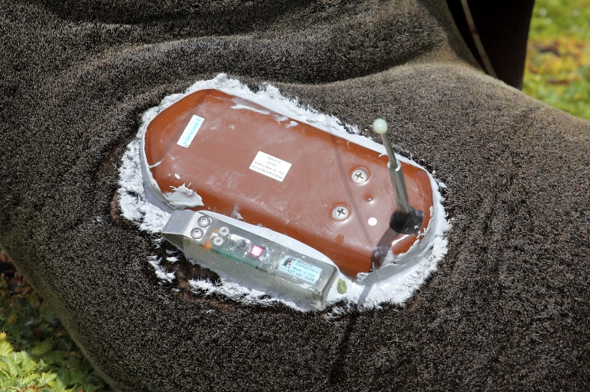



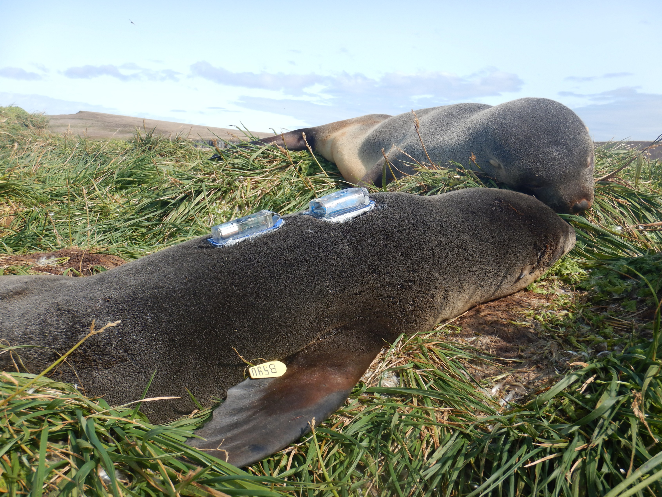 Label sensors

Figure : A schematic of an MK9 and SPLASH tag (Adapted from Wildlife computers product feature sheets).

### Tracking data and horizontal area restricted search (hARS)

Interpolated tracking data from Wege *et al.*, 2016 was used for describing surface movements of seals in this study. Wege *et al.*, 2016 used state space models (SSMs) to filter all tracking data which contains inherent errors ranging from 0.5 to 10 km on average (Costa *et al.*, 2010) producing locations with ~5km accuracy. These SSMs also allow inference of behavioral states based on horizontal area restricted search (hARS) modes along seal tracks providing information about whether a seal is foraging/resident or travelling/transient. Diving data were then filtered to overlap in time with location data thus excluding dives that did not have corresponding location data. Dives were grouped to the closest interpolated location in time along the seal track using dive start time (GMT) as reference. Behavioral modes inferred from SSM results were then appended to the dive record for later dive-wise analyses (Arthur *et al.*, 2016). All dive analyses are thus based on filtered dive locations.

Devices collected time in Greenwich Mean Time (GMT) which was converted to local time based on the geographic position of the seal at that time (local solar time ¼ GMT+(degrees longitude)/15). Dives were grouped into diel phases based on local times of each dive versus local times of sunrise, sunset and the nautical twilight (when the geometric centre of the sun is 12° below the horizon), calculated using NOAA’s solar calculator in the ‘maptools’ package in R (Bivand & Lewin-Koh 2016; R Core Team, 2020) to examine the effect of ‘time of day’ on environmental and behavioral metrics. The respective diel phases were ‘day’, ‘dawn’, ‘dusk’ and ‘night’. Lastly, all tracks were separated into individual foraging trips by using wet-dry tag periods.

‘Raw ARGOS data was extracted using the ARGOS-tools extension in ArcView (v 3.3). Females were considered as ‘on-land’ when the dive recorder measured a dry-period or for those devices where no diving behaviour was available, through visual inspection of location points by determining whether the point was on land or at sea. Bayesian State-space models were fitted using Markov chain Monte Carlo in ‘rjags’ (Plummer 2016), via the ‘bsam’ package (Jonsen *et al*. 2005; Jonsen 2016) implemented in programme R (R Core Team 2020). A hierarchical formulation allows for estimation of parameters for multiple animals and their individual foraging trips (Jonsen *et al*. 2006). **An inter-step duration of 2.5 hours was chosen based on the median number of Argos location points per day (9-10 points per day).** Two Markov chains were run in parallel, each of 50 000 iterations, using only every 200th value, while the first 10 000 values (i.e., burn-in) were excluded. Diagnostic plots were used to assess converging and appropriate mixing of the two Markov chains (Jonsen *et al*. 2013).’

To distinguish foraging areas from non-foraging areas in the tracks, a state-space model (SSM) was fitted using a two-state switching correlated random walk model in R (R Development Core Team 2012) and WinBUGS (available online: http://www.mrc- bsu.cam.ac.uk/bugs/winbugs/contents.shtml) as described in Breed *et al*. (2009). To fit the model, two Markov Chain Monte Carlo chains (MCMC) were run for 10 000 iterations, with a burn-in of 7000, sampling all model parameters and each regularized location estimate (which are estimated like parameters). Every fifth point of the 3000 remaining samples was retained for a net of 600 MCMC samples in each chain. From these 600 samples a mean and variance for each location estimate and model parameter was calculated. SAFS from MI only dive at night (chapter 2), therefore multiple interpolation time-steps were tested to see how foraging and non- foraging areas within the interpolated SSM tracks compared with night (foraging) and day (non- foraging) location fixes from the original tracks. Using a time-step of 120 min searching/foraging locations compared the best to night-time locations from the original tracks and was subsequently used to interpolate points. Distance travelled (km) and bearing (radians) from MI as well as between consecutive points were calculated with the 'argosfilter' package in R (Freitas 2010; R Development Core Team 2012).’

### Vertical area restricted search (vARS)

The time-depth data were corrected for drift in the pressure transducer using a zero-offset correction ‘offset’ method in R (R Core Team, 2020) at 2-hour time steps using a correction factor of 1. Dives in this study were defined as seal movements deeper than 4m for a given subsurface period exceeding 60sec. This customised threshold method was used to: maximize computational efficiency, allowing for effective use of a broken stick model (BSM) (Heerah *et al*., 2014), exclude prey handling behavior, remove travelling or other non-foraging activities, and conform with methods in other studies for comparative reasons (Does the BSM perform better with deeper/longer dives?). Consequently, 32.98 ± 2.74 % of total dives per seal have been retained for further analysis. For each dive, the maximum dive depth [m] and duration [s] was calculated. The post dive surface interval (pdsi) [sec] of a dive was defined as the amount of time it takes for the seal to transit from when it surfaces above 4m after a dive until it dives again below 4m.

It is common for dive duration to increase with dive depth among fur seals (Croxall and Gentry, 1987), suggesting that they mostly dive within their physiological limits. However, any oxygen reserves may allow for longer than usual pursuits in case the prey avoids capture (Georges *et al*., 2000). This can be represented as a dive residual, estimated in this study using the Pearson residuals from a linear mixed-effect model (LMM) fitted via restricted maximum-likelihood estimation (REML) with individual seal fit as a random term, using the package ‘lme4’ (Bates *et al.*, 2015). The dive residual gives an indication of whether the duration of dives for a given depth was longer or shorter than expected (e.g. Bestley *et al.*, 2015). Similarly, surface residuals can be estimated to represent cost of diving (Bestley *et al.*, 2015) using Pearson residuals from a LLM of the relationship between total duration of a given dive and the post dive surface interval (Figure 8). Higher surface residuals indicate increased time for blood and muscle oxygen levels to be replenished, indicating increased energy expenditure (Bestley *et al.*, 2015). Energy expenditure can therefore be related to whether, for a dive of a given duration, the pdsi was relatively long or short. Before this could be accomplished, dives whose pdsi were greater than

x(m) + 3*(x(u)-x(m))

, where x(m) is the median pdsi and x(u) is the mean pdsi,equating to ~900 sec (~15min), were ignored (1.787 ± 0.097 % of dives per seal) by using Underhill & Bradfield 1996 method for inspection of strays in data. This threshold was determined to constrain the surface residual model, thereby excluding the last dive of each bout. A bout was categorised as a group of dives (minimum 3 successive dives) occurring within at least 6hrs of each other independently for each foraging trip. Only dives taking place during a foraging bout were used in initial cluster analysis, however after including all dives it was found that inclusion/exclusion of these dives did not alter grouping outcomes, thereby leading to inclusion in final analysis. Considering the poorly fitted surface residual model analyzed visually according to an obviously large variance and skewed distribution of residuals, this variable was excluded from further analysis.

From the remaining dive data (n = 348760 dives) a broken stick method (Heerah *et al*., 2014) was used to produce low-resolution profiles from original high resolution (~1m) time series data enabling derivation of within-dive foraging periods. From each reconstructed dive profile, we calculated a set of candidate foraging effort indices. To calculate the optimal number of broken stick points, a Gompertz model was fitted to the mean distance between the original profile and the reconstructed profile using a sequence of broken stick points between 3 and 30. The inflection point of this curve was determined as the optimal number of broken stick points to describe the original profile. If the Gompertz model did not fit the curve, a manual number of broken stick points were assigned to summarize the dive profile and continue facilitation of dive analysis. We chose 6 broken stick points as this was the median optimal number of broken stick points used for when the model did fit the data. Choosing more points would likely decrease residual error, but increase complexity with increased calculation times, while choosing less points could oversimplify the dive profile (Fedak *et al*., 2001; Heerah *et al.*, 2015, 2019). Although the number of iterations in the BSM is critical to the quality of the abstracted dive (Photopoulou *et al.*, 2015), slight overestimation of feeding time (Heerah *et al.*, 2019) is acceptable for the purposes of this study.

To optimize foraging during a dive, seals tend to decrease their vertical speed and increase the sinuosity of their movements (Dragon *et al.*, 2012; Heerah *et al.*, 2019). This phenomenon is known as vertical area restricted search (vARS) (Dragon *et al.*, 2012). Segments produced by the broken stick method within dives were thus categorized as either ‘foraging’ or ‘transit’ based on the duration, vertical sinuosity and vertical velocity between broken stick points using thresholds of 4 sec, 0.9 sinuosity and 0.4 m/s respectively. Some dives have multiple ‘foraging’ segments within a dive. Therefore the mean foraging depth per dive was determined as the mean depth of the longest (in time) ‘foraging’ segment within a dive (Photopoulou *et al.*, 2020). Refer to methods in Heerah *et al*., 2014, 2015 for further details. Vertical area restricted search was calculated as:

vARS = total hunting time/total dive time

where hunting time is the sum of durations of all ‘foraging’ segments within a dive and total dive time is the duration from when the seal descends below 4m to when it ascends above 4m (Arthur *et al.*, 2016). Similarly foraging indices can be derived from bottom effort and dive efficiency:

Bottom effort = bottom time/total dive time

assuming fur seals spend most of their time foraging in the bottom phase of dives (Dragon *et al.*, 2012), where bottom time is the amount of time [in sec] spent within the bottom phase of the dive. The bottom phase is the section of dive below 80% of the maximum dive depth calculated for each dive separately (Figure 7). *Dive efficiency* (Ydenberg and Clark, 1989; Lee *et al.*, 2015) shows how much a seal distributes time to the bottom phase of a dive relative to recovery time required for that dive calculated as:

Dive efficiency = bottom time/(pdsi + total dive time)

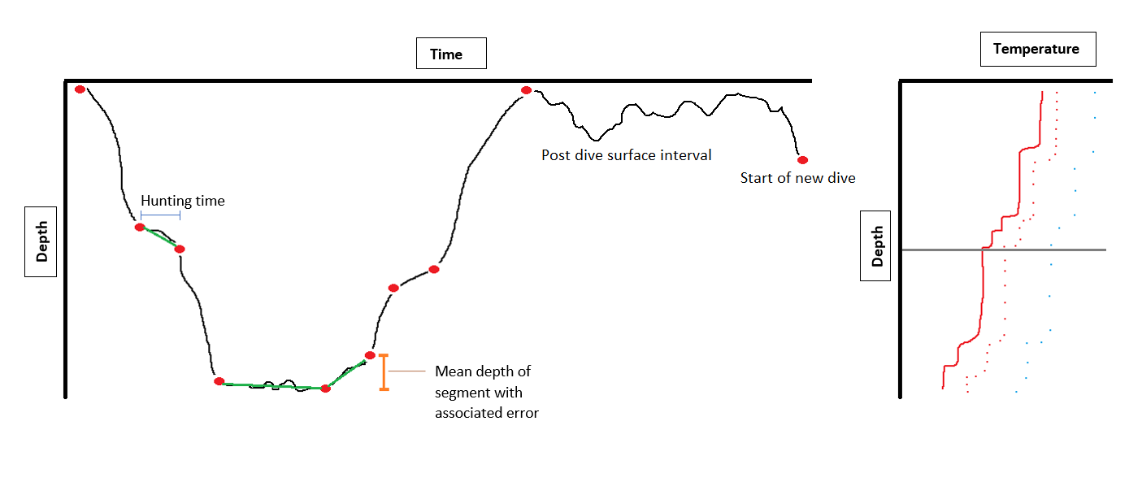

Total dive time

Thermocline depth

4m

80% of max depth

Bottom phase

Max depth

b)

a)

Figure : a) Schematic of a typical seal dive profile (black). The green segments within a dive are declared as 'foraging' segemnts according to the broken stick method, while the rest of the time the seal is predicted to be in ‘transit’ mode. Blue bars indicate the amount of time spent hunting within a foraging segment. The orange bars depict the distance over which a mean foraging depth is calculated within a foraging segment with associated error as the vertical distance between the two broken stick points. The post dive surface interval is the amount of time it takes for the seal to transit from when it surfaces above 4m after a dive until it dives again below 4m. The bottom phase of the dive is defined as that below 80% of the maximum depth. b) Downcast interpolated (solid red), gridded (dotted red) and original (dotted blue) temperature profile.

### Classifying divetypes

The modelled accuracy of seal positions is such that estimated locations within about 5 km of the colony may still represent the animal residing on land (Patterson et al., 2010). Furthermore, seals may behave differently during overnight foraging trips compared to longer foraging trips. This is likely due to the different environmental conditions experienced close to the island relative to those experienced further afield, explained by the island mass effect (Boden, 1988) and topographic influences on ocean dynamics (Perissinotto *et al*., 2000). For results to be spatially robust, only trips in which the animals travelled ≥5 km from the colony were considered in our analyses. However, to exclude any island-seal or inter-island-seal (Prince Edward and Marion Island) interactions and to differentiate discrete oceanic zone excursions, dives occurring within overnight foraging trips and short trips where the total distance travelled was less than 40kms from Marion Island were dropped. This meant focus was on open ocean seal responses to ocean conditions in line with the objectives of this study, resulting in 346680 (0.48% dives further excluded) dives available for following analyses, of which only 5895 dives were during the day.

Why I used different models for summer vs winter?

Interpreting foraging strategies relies on the time and space scale considered (Arthur *et al.*, 2016). Broad principal strategies (e.g. seasonal, annual, within a lifetime) may include short-term decision-making components (e.g. single dive, bout, foraging trip) (Arthur *et al.*, 2016). This study focusses on small scale (divewise) foraging behaviour.

There is extensive evidence of major seasonal differences in intrinsic and extrinsic seal behaviours previously determined in other studies (Arthur *et al.*, 2016; M Wege *et al.*, 2016; Wege *et al.*, 2019) as well as known seasonal trends in Southern Ocean stratification and mixing (Dong *et al.*, 2008; Sallée *et al.*, 2010; Du Plessis *et al.*, 2019). Therefore, including seasonality in a single model may obscure the signal (Seal diving response to thermal water column structure) that this study wishes to investigate. In line with the objectives of this study and data domain knowledge, hereafter data was split into summer and winter and treated separately in model analysis.

Akin to the way McDonald *et al.*, 2009 grouped seals into similar foraging strategies based on several variables to reduce dimensionality of diving behaviour, the methods in this phase of the study aimed to describe seal behaviour by grouping similar dives. Following a preliminary analysis of diving behaviour, seal dives were classified into two types (k=2) to produce a binary response variable summarising diving behaviour. This limited the number of mixed effects models required to describe diving behaviour responses to ocean stratification in later analysis. The optimal number of clusters were validated by means of a silhouette analysis. The silhouette analysis measures how well an observation is clustered by estimating the mean distance between clusters for different values of k. A "euclidean" metric was used for calculating dissimilarities between observations, which is the square root of the sum of squared distances between observations. (Rousseeuw, 1987). The appropriate number (k) of homogenous clusters/groups is the one that maximize the average silhouette width over a range of possible values for k. Two previously unknown groups were thus identified using the Clustering for Large Applications (CLARA) algorithm suggested by Rousseeuw and Kaufman, 1990 for large data sets like this (more than several thousand observations). CLARA is an extension to k-mediods (PAM) methods to reduce computing time and RAM storage problems using a sampling approach (Kodinariya and Makwana, 2013). In this study 50 samples were randomly drawn from the large dataset and the PAM clustering algorithm (Kaufman and Rousseeuw, 1990) was applied on these samples to generate an optimal set of medoids. CLARA then assigned all objects in the dataset to clusters, while repeating the sampling and clustering process, subsequently selecting the set of medoids with the minimal cost as the final clustering result used to alleviate sampling bias (Wei *et al*., 2000).

Prior to cluster analysis, the variance inflation factor (VIF) was calculated for each variable as well as a principle component analysis (PCA) and simple correlation matrices between variables (see appendix for more details) to remove highly correlated and collinear variables (Zuur *et al*., 2010), for dimension reduction (McDonald *et al.*, 2009), for simpler interpretation of divetypes and to preserve variance (Zuur *et al*., 2010). A VIF threshold of 10 was used to remove variables with higher VIFs according to methods in Quinn and Keough, 2002. In cases where variable Pearson correlations exceeded r=0.7, the variable contributing more to variance, calculated using the PCA analysis, was kept for further analysis and the other dropped.

### Thermal water column structure and vertical mixing

Not all environmental variables are relevant, and we don’t want model cluttering.

Three variables were produced to represent and describe thermal water column structure and vertical mixing experienced by the seal per dive:

1. Thermocline presence (stratified vs mixed)
2. Stability using Nt
3. Mean temperature of the water column.

Motivating for the use of the term ‘mixed layer depth’ (MLD) instead of ‘thermocline depth’ in this study required supporting studies and included the use of an external and independent data source with salinity readings. Validation of mixed layer depths therefore included exploration of density to access local water column stability. The MLD is conventionally calculated using density, relying both on temperature and salinity readings along with pressure/depth measurements (Huang *et al.*, 2018). Devices in this study only collected temperature data used to calculate thermocline information. further thermal methods

The new version (EN.4.2.1.) of the Met Office Hadley Centre EN series of data sets, with temperature and salinity measurements sufficiently allowed for this process. The data is downloaded (on the 19th Jan 2018) as global quality-controlled subsurface ocean temperature and salinity profiles and monthly objective analyses formed from the profile data with uncertainty estimates (Good, Martin and Rayner, 2013)

(<https://www.metoffice.gov.uk/hadobs/en4/download-en4-2-1.html>). Data is sourced from all types of available ocean profiling instruments such as Argo floats and corrected using methods in (Gouretski and Reseghetti, 2010). For this study data, with a spatial resolution of 1˚, was extracted for the period 2009-2015 to overlap with seal deployment data. Data are gridded onto an uneven exponential depth grid where differences in depth increases with depth. We gridded data onto a constant 1m grid for comparison with uniformly gridded seal temperature profiles.

Gsw-python package and Mixed layer depths were calculated using in-situ density [(not density anomaly), kg/m^3] of seawater from Absolute Salinity [g/kg], in-situ temperature [(ITS-90), degrees C] and sea pressure [(absolute pressure minus 10.1325 dbar), dbar] according to IOC *et al*.,2010. A threshold method was used where any changes in density over 0.01 kg/m^3 were defined as the mixed layer depth.

Mean uncertainty in the upper 200m (Good *et al.*, 2013) figure …

Using thermocline depth as mixed layer depth.

Nt and why we could use it to get stability (buoyancy fluxes)

Nt, Ns and Nsq were calculated (Pellichero *et al.*, 2017) as the mean value over a constant depth range from the mixed-layer base to 15m directly below this depth. The dominant contributing factor to changes in density, whether it be the vertical change in temperature or vertical change in salinity, was investigated. If temperature contributes the most to changes in density, we can assume the mixed layer depth is closely related to the thermocline depth.

Show comparisons of thermocline depth between objective analysis and seal data. Are they similar for this area and time?

How we calculated alpha and beta for Nt and Ns calculations. Nt calculation for each depth using where alpha = -0.000125 (average for this area using UK.MET objective analysis product) and g = 9.8 [m.s-2]

To produce downcast temperature profiles, temperature readings continuously recorded throughout a single dive were reduced to only measurements taken during the descent phase of the dive. The descent phase of a dive begins when the seal first moves below 4m and ends as the seal reaches its maximum depth of the dive. The mean descent and ascent rates of SAFS at Marion are similar (Mia 2016), thus making the choice of upcast or downcast profiles null in void. Temperature readings within each downcast was ordered by depth (instead of time) from shallowest to deepest and gridded onto a 1m custom vertical grid.

Patches of enhanced sinuosity in vertical movements of seals may have the potential to result in small-scale (<1m,<10sec) artificial mixing of water parcels, driving advection of thermodynamic properties such as temperature vertically in the water column. It is assumed in this study that the rapid response of tags and the conservative/insensitive thresholds used for determining thermocline depths prevented the influence of artificial vertical mixing on distinguishing thermocline presence. Thermocline depth was defined according to a hybrid method, where both a threshold and gradient method was employed. DeltaT = 0.25, gradient = 0.1 – check R script for confirmation. Motivate as to why these thresholds. Where the first derivative of temperature with depth is greater than 0.1 DegC and temperature difference between surface and given depth greater than 0.25 DegC with reference depth of 10m.

Stability and the assumptions associated with it. Only used the thermal component of the Brunt Vasala equation. These explanatory variables have different scales, so they are standardised by scaling before further analyses.

The devices deployed on SAFS and AFS do not collect sufficient data for the calculation of mixed layer depth. …Novel and important. Mixed layer depth, an important oceanographic and biological parameter (Dong *et al.* 2008; Kara *et al.* 2000; Lowther *et al.* 2015; Roquet *et al.* 2013; Thomson and Fine 2003). The mainstream approach for deriving mixed layer depth is using density changes. MLD derived as we expect a relationship with foraging behaviour due to..

Furthermore differences were calculated between the mixed layer depth and the maximum depth/foraging depth of the seal to investigate how far the seals are diving/foraging from the mixed layer depth.

### Generalized Additive Mixed-Effects Models (GAMMs)

Multiple techniques have been developed to fit the complex, non-linear relationships that often occur between mobile predators and their surrounding environment (Leathwick, Elith and Hastie, 2006). Owing to potential misclassification and inefficient algorithms to solve the computational complexity of such problems, especially in large datasets, classification and regression trees and neural networks are popular methods that are not suitable for this study. Another popular technique includes multivariate adaptive regression (MARS) which was not used in this study, because like Leathwick *et al.*, 2006 has shown, there is little difference in performance between GAMMs and MARS. They are both capable of modelling a binary response variable using a ‘binomial’ family distribution.

GAMs.

These two divetypes effectively summarize seal behaviors and could be used as a binary response variable in GAMMs to investigate the influence of ocean stratification on general seal diving behavior.

Generalized models therefore provide a common framework for modelling binary response variables such as divetype and can address dimensionality in multivariate nonparametric regressions.

allowing for smoothing to estimate non-linear trends in time series data and the use of tensor interactions between variables with incomparable units to moderate interactive variables independent of univariate effects on the response variable. Internal smoothing combats autoregressive processes in the data which may arise from increasing trends in maximum depth and dive duration observed for each seal over time (Burns *et al.*, 2008). Furthermore, including seal ID as a random effect in the model controls Type I error rate, tackles autocorrelation and increases detection power among individual variation (Schielzeth and Forstmeier, 2009).

Collinearity among predictors can cause several problems in model interpretation because those predictors explain some of the same variance in the response variable, and their effects cannot be estimated independently (Quinn & Keough, 2002; Graham, 2003) (Harrison *et al.*, 2018). To satisfy the requirements of minimal collinearity between predictor variables a VIF threshold of 10 was considered.

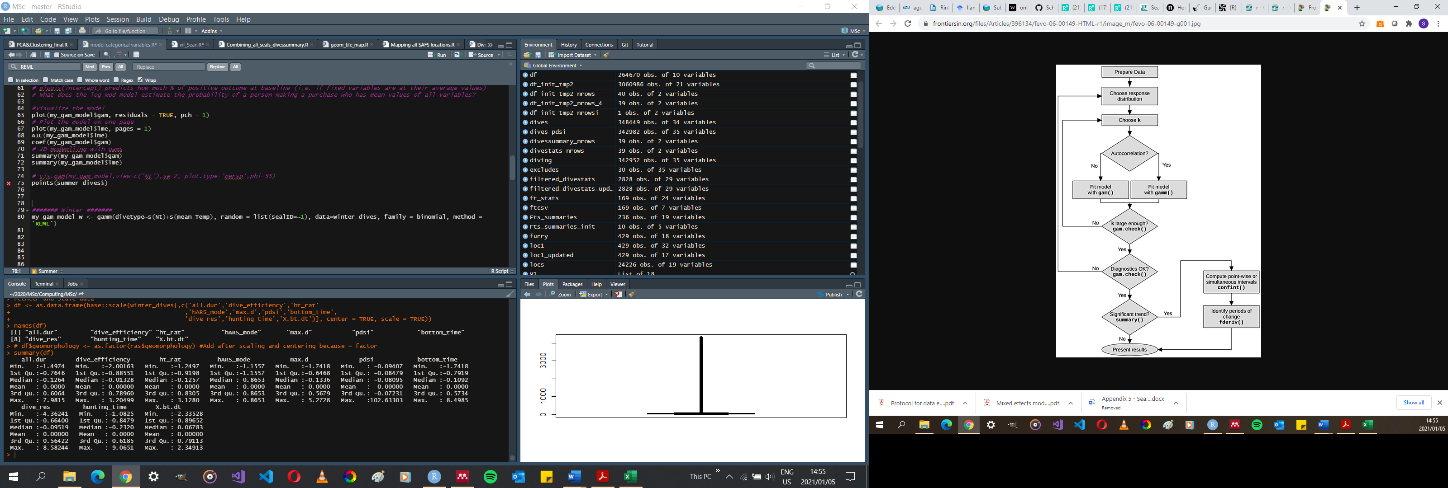Create own diagram for my analysis.

As sample size increases both type 1 and type 2 error decreases, increasing the power of hypothesis testing.

Hypothesis testing in this study may or may not be practically meaningful because of the arbitrary large sample sets i.e. very small differences will be detected. Akin to this, some assumptions such as normality in the data were not met. Therefore confidence intervals were preferred - look at a CI for the difference in means* - it should exclude 0 if the effect size was significant.

Data were tested for normality and homogeneity of variances prior to analysis when necessary. Multiple ANOVAs were used to compare dive parameters between seasons and thermocline presence. Multiple ANOVAs were also used to compare fixed effects between divetypes prior to GAMM model runs. All means are expressed as mean ± SD unless otherwise stated and results were considered significant at p < 0.05.

## Results

### General and seasonal seal movements

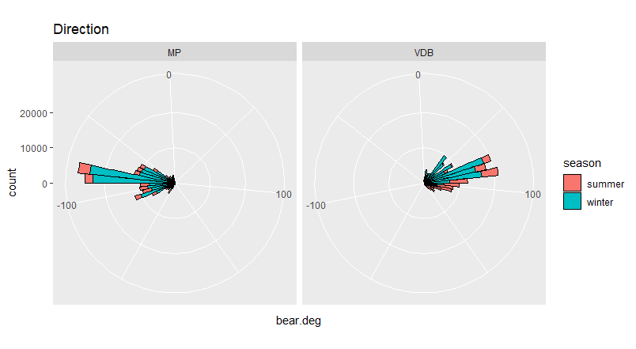

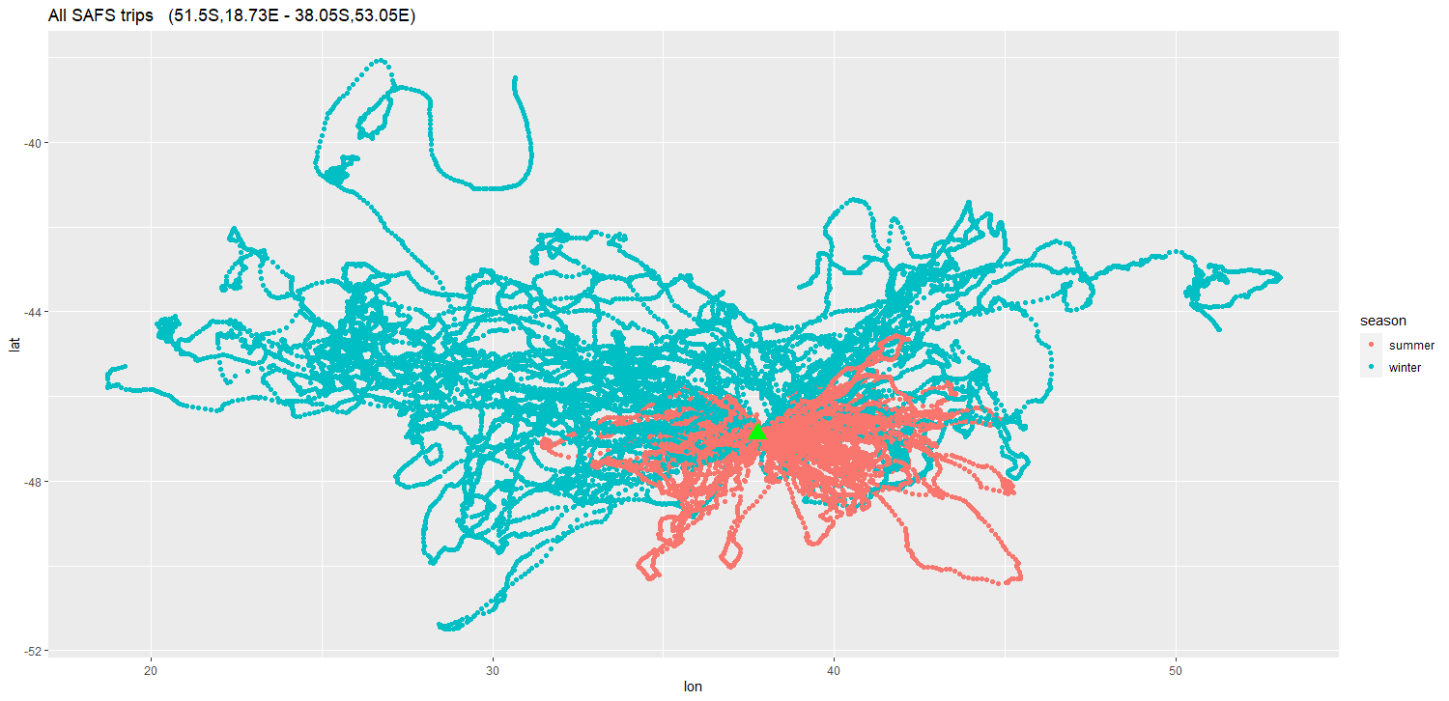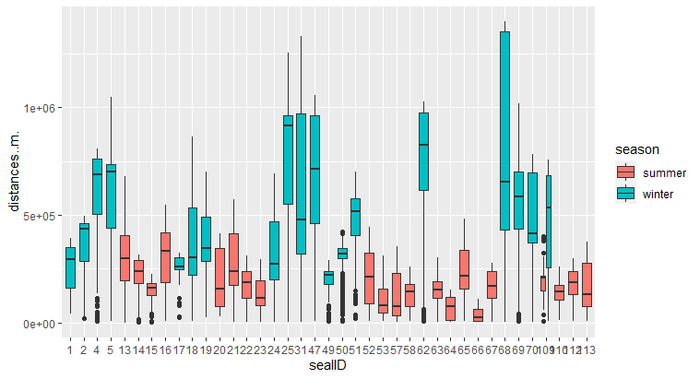

In total, 346760 dives were analysed, of which only 5899 (1.70%) dives were during the day. Dives performed between 15 October and 15 April were considered summer dives (n = 82090 (23.67%)), while winter dives spanned 15 April to 15 October (n = 264670 (76.33%)). Despite more foraging trips available for analysis in summer (n = 126), because winter mean foraging trips (n = 43) were significantly longer (length = 38.698 ± 3.514 days, distance = 2037.797 ± 169.37 km) (Kruskal-Wallis X2 = ,P<0.0001) and further from Marion Island than foraging trips in summer (length = 8.654 ± 0.395 days, distance=503,583 ± 28,673 km), the number of bouts and dives are higher in winter (bouts = 791.567 ± 48.475, dives = 6196.628 ± 728.31) as opposed to summer (bouts = 8.59 ± 0.359, dives = 791.567 ± 48.475). The overall average number of dives per bout came to 134 ± 85.

Table : Seasonal foraging trip statistics of female Arctocephalus tropicalis from 2009-2015 deployments. Values are mean ± SE.

|  |  |  |
| --- | --- | --- |
| **Foraging trip (FT) stats** | **Summer** | **Winter** |
| **#Seals** | 20 | 19 |
| **#Foraging trips** | 126 | 43 |
| **Mean FT #bouts** | 8.59 ± 0.359 | 39.8 ± 3.53 |
| **Mean FT #dives** | 791.567 ± 48.475 | 6196.628 ± 728.31 |
| **FT total distance travelled [km]** | 503.583 ± 28.673 | 2037.797 ± 169.37 |
| **FT duration [days]** | 8.654 ± 0.395 | 38.698 ± 3.514 |
| **Median #dives per location** | 10 | 18 |
| **Total hunting time per FT [sec]** | 19759.058 ± 1306.188 (~5hrs) | 228685.442 ± 22824.448 (~64hrs) |

Table : Seasonal diving statistics of female Arctocephalus tropicalis from 2009-2015 deployments. Values are mean ± SD except for median post dive surface interval (pdsi) which is represented as mean ± SE.

|  |  |  |
| --- | --- | --- |
| **Diving stats** | **Summer** | **Winter** |
| **#Dives** | 82090 | 264670 |
| **Max depth [m]** | 51.503 (17.908) | 56.903 (29.225) |
| **Dive duration [sec]** | 98.192 (26.845) | 124.347 (42.304) |
| **Dive efficiency** | 0.329 (0.14) | 0.342 (0.171) |
| **Bottom time [sec]** | 52.714 (23.07) | 61.681 (33.69) |
| **Hunting time [sec]** | 24.941 (22.215) | 36.911 (34.097) |
| **Proportion of dive spent hunting [%] vARS** | 24.206 (18.699) | 28.547 (22.843) |
| **Proportion in bottom phase [%]** | 52.998 (15.788) | 49.475 (20.443) |
| **Hunting depth [m] (only when hunting)** | 44.815 (16.716) | 46.204 (25.841) |
| **Mean pdsi (SD) [sec]** | 604.288 (6863.279) | 296.874 (3123.849) |
| **Median pdsi (SE) [sec]** | 52 (23.954) | 44 (6.072) |
| **Dive residuals** | -0.14 (21) | 0.003 (29) |
| **% Thermocline presence** | 23.11 | 4.778 |
| **Nt [1/s2]** | 0.446 (0.837) | 0.027 (0.31) |
| **Mean Temperature [DegC]** | 6.897 (1.065) | 6.973 (1.382) |

### Diel phase patterns

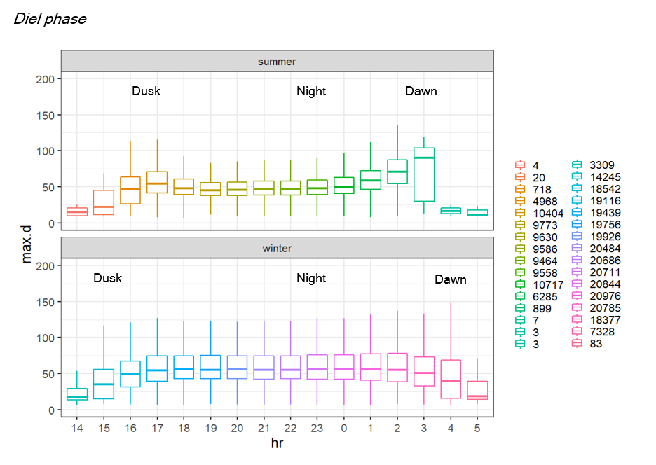

Summer dives

Winter dives

Figure : a) Summer and b) Winter maximum depth with diel phase (Change y axis limits). Colours correspond to the sample number of dives used to calculate boxplots for each hour based on local time of dives. In summer, seals follow diel vertical migration to optimize energy-efficiency in prey capture.

What is causing the changes in max.d with diel phase? Does the daily solar cycle have an influence on divetype and could this be related to temperature? (Check correlations between diel phase and divetypes). Should not find anything as 303407 dives at night while only 42673 dives make up the rest and divetypes are split fairly evenly in clustering.

Due to the disproportionally skewed number of dives towards ‘Night’ dives (87.51% of dives), and the relatively evenly spread overall clustering of divetypes (divetype 1 = 166046 dives; divetype 2 = 180714 dives) it is unlikely that diel phase would have an influence on behavioral metrics. Therefore, diel phase was not used as a fixed effect in the gams model and the seasonal difference of changes in maximum dive depth with diel phase have been assumed to be attributed to

The summer dives are shallower at night because seals can exploit vertically migrating krill without needing to dive deeper similar to other studies in summer (Croxall *et al.*, 1985). However, in winter seals do not follow vertical migration of prey. This may be because when the extent of the mixed layer deepens in winter, myctophid fish perhaps do not shoal as shallow as they do in summer when mixed layer depths as shallower.

Because nights are longer in winter and so more dives can be performed (mean no.dives winter = 64 min; mean no.dives summer = 36 min), cumulative hunting time of all dives per night increases (mean ht winter = ±39 min; mean ht summer = ±15 min).

Figure 12 sheds light on how seals allocate their time when foraging. Seals dive deeper at dusk and dawn than during the night in summer, whereas in winter seals follow the vertical migration of prey, diving deepest at night.

 Kuhn

Percentage of time spent in vARS mode per dive between seasons, seals and WE (instead of colony differences). Proportion of divetype 2 between seasons, seals and WE. Cannot use ANOVAs because of non-normality, heterogeneity of variances (heteroskedasticity) and varying sample sizes. Therefore just show simple boxplots….

### Principal component analysis and corelations of behavioural variables

vARS was left out of cluster analysis due to its large r >0.7 with X.bt.dt and because it contributes less (summer= 9.83%,winter=9.58%) to variance than X.bt.dt (summer=11.79%,winter=10.95%) within the first two dimensions explaining summer=60.44 and winter=64.00 cumulative proportion of variance. Pdsi and hARS contributed the least to the variance in the data (PCA) and were excluded from cluster analysis.

Direct analysis of dives – dive summary data. I use max depth instead of foraging depth because they show the same distribution around similar means (Adjusted R-squared: 0.9379, F-stat: 3.891e+04, df = 2575, p < 2.2e-16). The proportion of dives spent in the bottom phase of dives is corelated to vARS (summer r^2 = 0.6274873, winter r^2 = 0.73746653) meaning seals forage mostly within the bottom phase of the dive. This is in support of other studies (Georges, Tremblay and Guinet, 2000; Hooker *et al.*, 2002; Weimerskirch *et al.*, 2007; Viviant *et al.*, 2016). Horizontal area restricted search was not corelated to vertical area restricted search (summer r = 0.061094906, winter r = -0.04899857)

### Cluster analysis: What kind of dives do SAFS perform?

Increasing the number of groups k in cluster analysis caused a decreasing trend in Silhouette widths in summer, meaning two groups were preferred for identifying dives with the most similar patterns (Summer Silhouette width = 0.3778962). Winter Silhouette widths increased slightly with increasing k, however, not enough to warrant using more than k=2 (0.3579933) for further analysis considering all other reasons for choosing k=2.

By analyzing the cluster averages, we could relate seal behavior to each of the two types of dives. Divetype one corresponded to dives with significantly lower foraging effort (p=), but significantly deeper dives in winter and summer.

Total dive duration is linearly related to maximum depth, and maximum depth is is corelated with hunting depth.

After vif for winter “bottom time” and “hunting time” have been excluded from the cluster analysis, leaving "all.dur" , "dive_efficiency", "ht_rat", "hARS_mode", "max.d", "pdsi", "dive_res”, and "X.bt.dt" to describe the two divetypes. For summer "all.dur" was also excluded from further analyses.

I’d expect hunting time to increase with dive depth and so maybe I could use a mixed model to get higher or lower than expected hunting time for a given dive (figures below).

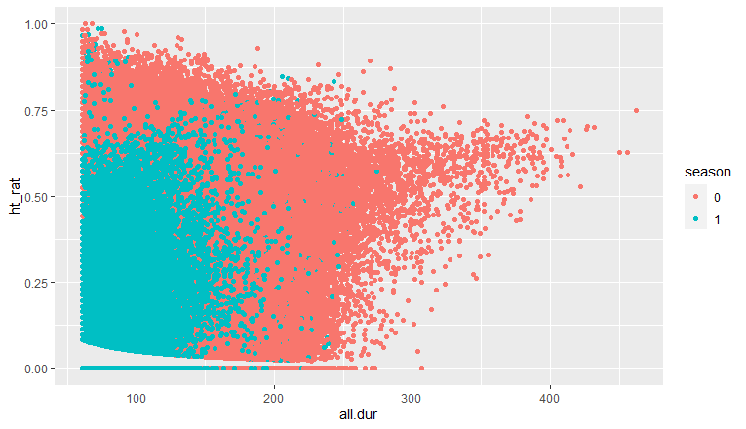

Figure : After about 4min dive duration, % dive spent hunting (vARS) increases. The upper limit of vARS tends to decrease with increasing dive time probably an artefact of the broken stick model methods.

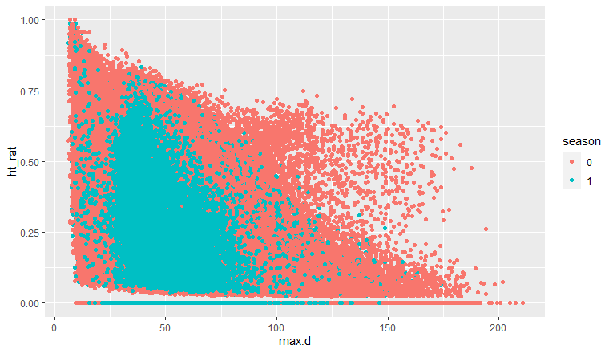

Figure : As maximum depth increases the upper limit of vARS decreases. After around 100m two modes of hunting tends to occur. Either around 50% of the dive or 0%.

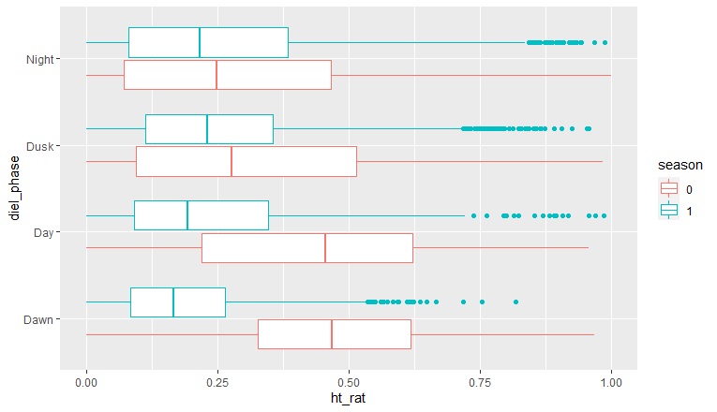

Figure : Proportion of dive spent hunting varies with diel phase and season.

According to the above graph, look at whether dives are shallower during the day and dawn in summer because of the relationship between ht_rat and max.d.

I need to get boxplots of variables with season, individual, ft, bout and diel phase to see whether fixed or random effects should be put into the model or not. Do these boxes vary e.g. with sealID randomly or do they vary according to e.g. season?

What is the effect of sampling frequency on deriving dive foraging indices? Does sampling frequency effect the distinction between thermocline presence and absence? Can we compare movement and foraging behavior between seals whose devices were set to read at different intervals?

Bottom time vs foraging time… Are they related and which should be used in further analysis (linear mixed models)?

### Ocean Stratification and diving behaviour

Nt validation – contributing the most to buoyancy fluxes

|  |  |  |  |  |
| --- | --- | --- | --- | --- |
| **Season:** | **Summer** | | **Winter** | |
| **Thermocline presence** | Thermocline absent | Thermocline present | Thermocline absent | Thermocline present |
| **# Dives** | 63119 | 18971 | 252024 | 12646 |
| **% Divetype 2** | 62.27 | 42.59 | 51.21 | 33.75 |
| **Dive_duration** | 96.904 (26.833) | 102.474 (26.438) | 123.841 (42.069) | 134.424 (45.604) |
| **Dive_depth** | 49.476 (17.504) | 58.249 (17.585) | 56.25 (29.114) | 69.932 (28.359) |
| **Bottom_time [sec]** | 53.302 (23.378) | 50.759 (21.903) | 61.856 (33.616) | 58.174 (34.959) |
| **vARS (only when hunting)** | 0.26 (0.189) | 0.182 (0.166) | 0.289 (0.229) | 0.209 (0.211) |
| **Dive_residual** | -0.275 (20) | 0.309 (21) | -0.205 (29) | 4.148 (31) |
| **Dive_efficiency** | 0.341 (0.141) | 0.292 (0.128) | 0.345 (0.171) | 0.281 (0.148) |
| **mean pdsi (SD) [sec]** | 524.209 (6910.965) | 870.72 (6695.468) | 295.468 (3130.285) | 324.898 (2992.683) |
| **median pdsi (SE) [sec]** | 50 (27.508) | 59 (48.611) | 44 (6.235) | 57 (26.612) |
| **Nt [1/sec]** | 0.093 (0.294) | 1.62 (0.976) | 0.003 (0.183) | 0.501 (1.054) |
| **Temp [DegC]** | 6.875 (1.1) | 6.972 (0.935) | 6.979 (1.359) | 6.857 (1.765) |
| **dist_to_thermocline** | NaN (NA) | +10.124 (17.163) | NaN (NA) | +7.607 (29.115) |
| **Mdepth_hunting (only when hunting)** | 43.248 (16.252) | 50.595 (17.129) | 45.654 (25.618) | 58.237 (27.701) |
| **max_diff_therm** | NaN (NA) | +17.401 (16.913) | NaN (NA) | +18.765 (28.075) |
| **Therm depth** | NaN (NA) | 40.848 (17.979) | NaN (NA) | 51.167 (27.452) |

### Response of diving behaviour to ocean stratification

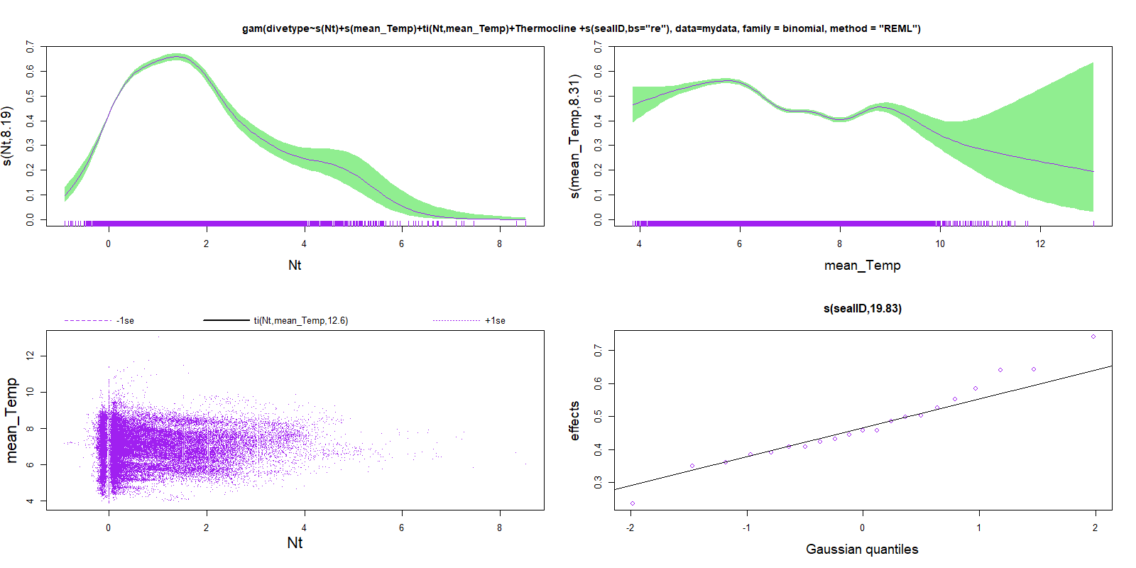

mean Temp of the downcast experienced by the seal does not act as a cue for the types of dives performed. The bump in the graph is probably related to the location of those dives…

Is the smooth effect sufficient to leave the model residuals independent? Then you do not necessarily need to do anything to correct the model (no auto-correlation).

No model is perfect and so to show the general response of divetype to Nt and mean_Temp we have plotted boxplots describing their relationships. Does stability elicit a response in diving behaviour?

How far from the thermocline do the seals forage(foraging depth)/dive(max.d)?

## Discussion

### General and seasonal seal movements

Tropicalis diving and foraging behaviour (will mostly be horizontal ARS). Marine predators target edges of eddies and large ocean fronts. SAFS decline in pup population? Why? Lets look at Fine scale oceanographic influences on foraging behaviour and see if this might have an effect on. Can write off oceanography as a driver of pup population decline because foraging effort is not influenced by oceanography. It is probably due to intrinsic changes in population, competition for breeding/pupping space on beaches (do fur seals mate on land or at sea?)…

A lot more foraging happening in winter to replenish demands of long weaning period and possibly supplement new pregnancy now that they are able to leave for longer trips.

### Diel phase patterns

Some marine top predators, such as gentoo penguins (Lee *et al.*, 2015), King penguins (Bost *et al.*, 2002) and subantarctic fur seals (Georges *et al*., 2000; Wege, 2013; Mia Wege, 2017), change their diving behavior according to time of day. Such diel dive patterns are consistent with nychthemeral vertical migration of prey (rising to the surface at night) during summer (Klages and Bester, 1998; Georges *et al*., 2000; Bost *et al.*, 2002), however Wege, 2017 and this study has illustrated that winter diel trends of SAFS at Marion Island cannot be attributed to the same cause. Mixed layer depths (mlds) that are closely associated with the distribution of prey in the water column (Koubbi *et al.*, 2011) are deeper in winter than in summer ((de Boyer Montégut *et al.*, 2004)this study and others). Hence, seals must dive consistently deeper and longer in winter across all diel phases to reach prey.

Seals appear to continue foraging efforts into the ‘dawn’ phase of the diel cycle in summer by following their vertically migrating prey to deeper depths also observed at Macquarie Island (Goldsworthy, 1997) and Ile de la Possession (Luque *et al*., 2008), but unlike subantarctic fur seals at Amsterdam where seals appear to become satiated by dawn (Georges *et al*., 2000).

The data collected should be uploaded to the Marine Mammal Exploring the Oceans Pole to Pole (MEOP) consortium.

By ignoring intra-year and intra seasonal temporal trends in seal behaviour and physical oceanographic conditions in the Southern Ocean in our models we may be missing auto-correlative effects that could bring about a new set of results in our data.

No evidence of partitioning certain zones to reduce inter-species and intra-species competition?

Seasonal trends: These findings suggest that general differences in seasonal foraging behavior may be primarily driven by seasonal patterns in pup attendance and greater winter pup fasting ability, instead of by abiotic trends such as the mixed layer depth seasonal cycle. (Do smaller scale findings validate seasonal scale results?)

Niche partitioning in AFS relaxing competition allowing for con-specifics to co-exist (Jones *et al.*, 2020).

## Conclusion

The methods in this study of grouping dives into two main divetypes were highly specific for the SAFS population at Marion Island and for the aims of this study. It should therefore be noted that these methods might not be useful for investigating similar foraging patterns in other study species or even in other populations of the same species who may, for example, perform several dive types related to foraging effort. Similarly, the use of a gams model was chosen specifically for modelling a binary response variable, in this case one of two divetypes, and may also not be applicable.

Although this study aims to contribute to the growing understanding of marine mammal biologging data, further studies with explicit management and conservation implications should be produced due to the paucity of such papers (McIntyre, 2014).

SAFS tend to remain within the EEZ of the Prince Edward Islands and mostly within the extent of the MPA making them and their prey relatively well protected. If Southern Ocean fronts continue to be a major source of prey for fur seals, shifting fronts may drive seals further from Marion not only creating a potential problem for dependent fasting pups with limited fasting abilities, but also reducing their legislative protecting and that of their prey (also further away from the MPA).

Because fur seals forage most nights throughout their foraging trip (from start to finish how many days were spent diving?) it is assumed that seals are opportunistic foragers whose movements are not entirely driven by environmental conditions (Mia et al).

## Acknowledgements

## Supporting information

Longer night durations in summer allows for increased opportunities for feeding (Arthur *et al*  2016).

Heerah *et al* . 2019 used data from head-mounted accelerometers to validate the use of time-depth measurements to derive reliable dive foraging indices. Found that >93% of established processing procedures matched that of the broken stick method (foraging segments within the dive).

# Chapter 3: Topographic influence on downstream submesoscale variability: A case study at Marion Island using seal-borne data loggers

Sean Evans, Marcel du Plessis, Mia Wege, Isabelle Ansorge, Nico de Bruyn

Alternative chapter titles: Dive and foraging behaviour responses to submesoscale (1-20kms,12hrs-5days) ocean variability OR The influence of submesoscale ocean fronts on Subantarctic fur seal movements OR Influence of submesoscale Southern Ocean variability on the movement of a top marine predator of the Subantarctic domain

Disclaimer: This chapter is prepared for publication in (what journal?).

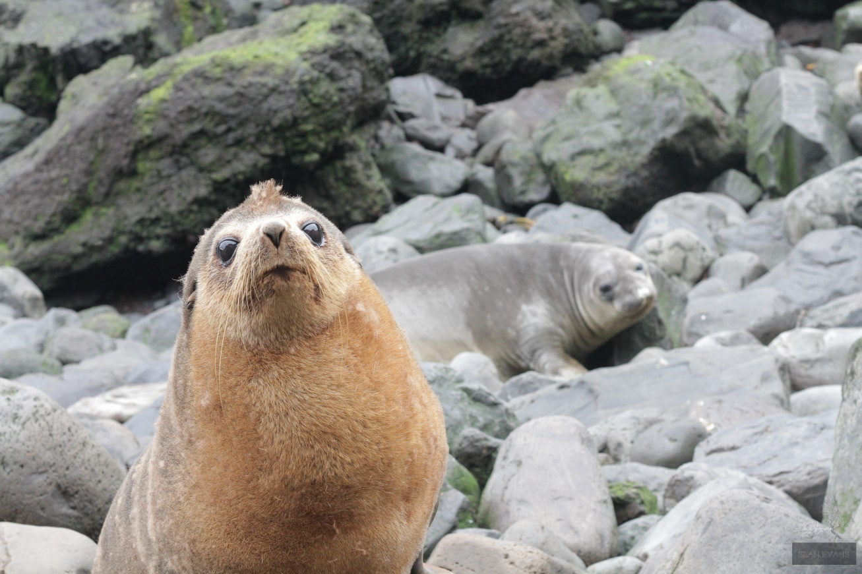

13 SubAntarctic fur seal bull holding his territory with a southern elephant seal in the background

## Abstract

Autonomous sampling platforms have taken the scientific community by storm.

Mesoscale eddies drive submesoscale flows in the Southern Ocean.

## Introduction

Replicate (Rosso *et al.*, 2015)

De Bruyn 2009 Bathymetry effect on foraging – East of the island downstream effect. Look at this paper for references of oceanography.

### Southern Ocean and Prince Edward Islands

The Southern Ocean is generally low in nutrients with ephemeral spring phytoplankton blooms contributing substantially to Southern Ocean productivity (Smetacek and Nicol, 2005). Blooms tend to occur on island shelves and along ocean fronts within the Antarctic Circumpolar Current (ACC) when nutrients become available through interactions between the sea floor, water mass properties and ocean currents (Moore and Abbott, 2000). The Prince Edward islands are of particular importance to scientists studying the Southern Ocean system due to its pristine state and associated surrounding ocean dynamics (Ansorge *et al.* 2014; Lutjeharms and Ansorge 2008). Marion Island is the larger (270 km2) of the pair of islands, with Prince Edward (45 km2) situated 19 km’s northeast of Marion (Lutjeharms and Ansorge 2008). These islands are young and volcanic (shield volcanoes) in origin (< 1 mil yrs old) and are situated in the roaring forties and north of the furious fifties (Ansorge *et al.* 1999). They lie in the path of the Antarctic Circumpolar Current (AAC) (Lutjeharms and Valentine 1984; Lutjeharms 1985) within the Polar Frontal Zone (PFZ) with the Sub-Antarctic Front (SAF) to the north and the Antarctic Polar Front (APF) to the south (Ansorge *et al.* 2014; Emery 1977; Hofmann 1985; McQuaid & Froneman 2004; Pakhomov & Chown 2003; Pakhomov & Froneman 1999a; Screen *et al.* 2009). These fronts bound the ACC and are characterised by strong temperature, salinity and density gradients (Bost *et al.* 2009). In addition to major frontal systems, the islands experience eastward propagating mesoscale turbulence in the form of eddies (Ansorge *et al.* 1999; Ansorge and Lutjeharms 2005).

Although deep-reaching mesoscale fronts generated by the flow of the Antarctic Circumpolar Current over the South West Indian Ridge represent important foraging areas for these fur seals, little is understood about the submesoscale. With the proposed shifting of fronts by climate change, fur seal foraging success may be impacted, with potential consequences for breeding success. What are the consequences here for seals? Relate this chapter to chapter one. What do we expect in terms of foraging ecology to the West and east of Marion considering the results from chapter 1 and based on findings of previous papers?

Read: (Froneman *et al.*, 1999) about plankton surrounding Marion to the west and east.

A well-defined downstream wake at Marion Island is evident using CTD profiles and a collection of nutrients and chl-a. Mixed layer depths seemed to be shallower within the wake of the island and deeper on to the East. Vortices associated with this wake showed some degree of spatial covariance with the distribution of chl-a.

(de Boyer Montégut *et al.*, 2004) – mixed layer depth over the global ocean.

### Topographic influences on submesoscale variability

Topographic influences on submesoscale variability:

Previous evidence for increased downstream submesoscale variability at Marion Island (Perissinotto, Lutjeharms and Van Ballegooyen, 2000).

### Telemetry

Animals act as autonomous ocean sampling platforms, increasing global coverage for improved monitoring of the world’s oceans (Harcourt *et al.*, 2019).

Despite modern advances in technology, high resolution measurements (<0.05˚) of fundamental oceanographic properties such as temperature remain scarce in the Southern Ocean (de Boyer Montégut *et al.* 2004; Lauro *et al.* 2014; Rintoul *et al.* 2010, Roquet *et al.* 2009; Treasure *et al.* 2017). Oceanographers have devised a range of instruments such as Conductivity-Temperature-Depth (CTD) recorders installed on ships to sample depth profiles of such ocean characterisics. These sampling efforts require deployment of dedicated personnel and ships. Ship measurements in the Southern Ocean are chiefly limited by hostile weather, ocean and sea-ice conditions that make ship operations slow, labour intensive, logistically challenging and expensive (de Boyer Montégut *et al.* 2004).

The implementation of autonomous Argo floats have considerably improved available information (Dong *et al.* 2008; Gould and Turton 2006; Gould *et al.* 2004; Robinson 2010), but large areas of missing data remain due to certain instrument impediments (Charrassin *et al.* 2008). The Argo floats drift with currents limiting the data to typically biologically uninteresting areas (Charrassin *et al.* 2008; Roquet *et al.* 2009).

Although satellites have allowed us to cover large areas of the Southern Ocean and produce extensive physical oceanographic data sets over short periods of time (Robinson 2010), high volumes of cloud cover and sea-ice cover prohibits sensors from observing the ocean surface (Charrassin *et al.* 2008; Rayner *et al.* 2003; Reynolds *et al.* 1989). Furthermore, most of these satellite products cannot penetrate to more than a few metres below the ocean surface, leaving large gaps in our understanding of subsurface ocean properties.

Animal-borne hydrographic data loggers on deep-diving and far reaching species have proven to be extremely useful in combatting this data deficiency problem by remotely sampling ocean properties (Mike, 2004; Mcmahon *et al.*, 2005; Treasure *et al.*, 2017; Harcourt *et al.*, 2019) (Balcerak 2014; Hussey *et al.* 2015; Roquet *et al.* 2013; Treasure *et al.* 2017). Data are cost-efficiently obtained in remote areas that are otherwise poorly sampled (Treasure *et al.*, 2017; Harcourt *et al.*, 2019) (Roquet *et al.* 2009). The simultaneous *in situ* sampling of both environmental and bahavioural parametres has improved our understanding of how these animals utilize their habitat (Bost *et al.* 2009; Tosh *et al.* 2012; Tosh *et al.* 2015), but also provides valuable hydrographic data for physical oceanographers (Roquet *et al.* 2013; Treasure *et al.* 2017; ). Some studies have already shown that the use of data loggers on seals has brought new oceanographic information from local to regional scales (Boehlert *et al.* 2001; Hooker and Boyd 2003; Lydersen *et al.* 2004), contributing to the Earth Observation Network and improving our understanding of the ocean properties (Roquet *et al.* 2013). In this study, seal-derived data will be used to investigate surface ocean stratification and inferred submesoscale variablity in the waters surrounding Marion Island.

Questions?

My main questions would be something like:

1. What is the general ocean climate around Marion island?
2. Seasonal variability?
3. Geostrophic velocities, mesoscale variability, ocean fronts and EKE.
4. Are fur seals targeting the mixed-layer depth and steep thermoclines?
5. Is the latitudinal variability of the Southern Ocean fronts picked up in the seal data?
6. Do we ensure full use of MIMMP fur seal device data from an oceanographic point of view?

We hypothesise that fur seal data can be used to create an environmental context for the assessment of downstream submesoscale variability.

Can we relate the submesoscale ocean variability to diving behavior.

## Methods

To address these questions the following methodology were carried out.

### Ethics statement

### Study site, animal handling and instrumentation

Where were the deployments made, with a map.

Device deployments: TDRs were attached to

### Seal movements and behavior

#### Horizontal movement metrics

Extracted from Mia PhD and MSc:

PhD - ‘Location information relayed through the global ARGOS satellite system contains inherent errors and some erroneous data. To account for this observation error we fitted a two-state, behaviourally switching, state-space model to Argos tracks (Jonsen *et al*. 2005; Jonsen 2016). State-space models filtered erroneous location estimates and provided interpolated tracks with locations at set time intervals. I did not use the behavioural mode estimates in these analyses given that the goal was only to determine female home-range and core habitat use. Prior to analyses, all seal tracks were split into individual foraging trips. Females were considered as ‘on-land’ when the dive recorder measured a dry-period or for those devices where no diving behaviour was available, through visual inspection of location points by determining whether the point was on land or at sea. Bayesian State-space models were fitted using Markov chain Monte Carlo in ‘rjags’ (Plummer 2016), via the ‘bsam’ package (Jonsen *et al*. 2005; Jonsen 2016) implemented in programme R (R Core Team 2016). A hierarchical formulation allows for estimation of parameters for multiple animals and their individual foraging trips (Jonsen *et al*. 2006). An inter-step duration of 2.5 hours was chosen based on the median number of Argos location points per day (9-10 points per day). I ran two Markov chains in parallel, each of 50 000 iterations, using only every 200th value, while the first 10 000 values (i.e., burn-in) were excluded. Diagnostic plots were used to assess converging and appropriate mixing of the two Markov chains (Jonsen *et al*. 2013).’

MSc –‘Raw ARGOS data was extracted using the ARGOS-tools extension in ArcView (v 3.3). Location data is assigned a location class (LC) based on the number of satellite messages received and is given an accuracy estimate. LC 3 is accurate to 150 m, LC 2 to 350 m, LC 1 to 1 km, LC 0, A and B have no estimate and LC Z is an invalid location.

To distinguish foraging areas from non-foraging areas in the tracks, a state-space model (SSM) was fitted using a two-state switching correlated random walk model in R (R Development Core Team 2012) and WinBUGS (available online: http://www.mrc- bsu.cam.ac.uk/bugs/winbugs/contents.shtml) as described in Breed *et al*. (2009). To fit the model, two Markov Chain Monte Carlo chains (MCMC) were run for 10 000 iterations, with a burn-in of 7000, sampling all model parameters and each regularized location estimate (which are estimated like parameters). Every fifth point of the 3000 remaining samples was retained for a net of 600 MCMC samples in each chain. From these 600 samples a mean and variance for each location estimate and model parameter was calculated. SAFS from MI only dive at night (chapter 2), therefore multiple interpolation time-steps were tested to see how foraging and non- foraging areas within the interpolated SSM tracks compared with night (foraging) and day (non- foraging) location fixes from the original tracks. Using a time-step of 120 min searching/foraging locations compared the best to night-time locations from the original tracks and was subsequently used to interpolate points. Distance travelled (km) and bearing (radians) from MI as well as between consecutive points were calculated with the 'argosfilter' package in R (Freitas 2010; R Development Core Team 2012).’

Check Mia MSc if needing directional information.

I did not include locations that were a certain distance? Away from Marion.

Preprocessing of data (>60secs and >4m deep). The depth resolution of the TDR’s were 1m. Therefore, only dives greater than 4m were included in analysis, thereby eliminating any travelling dives.

Bouts and how they were calculated. Bouts are separated by 6 hours between the start time of dives that are >4m and >60sec.

### Foraging metrics using broken stick model

Broken stick to get vertical foraging metrics. Inference of foraging activity within dives. Deriving variables using linear mixed models e.g. dive residuals. Foraging behavior incorporates foraging effort, dive cost, dive optimality(efficiency), relative foraging effort, foraging time

Straight from Arthur *et al*  2016: ‘Traditionally, the dive profiles of air-breathing marine animals are viewed as having three distinct phases: descent, bottom and ascent. More recently, the miniaturisation and increased memory and battery life of bio-logging instruments has enabled the collection of dive data at very fine resolutions (i.e. less than 1s) (Evans *et al* . 2013) revealing that the dives of many marine animals are considerably more complex. It is likely that the three-phase view of dives leads to an over-simplification of dive behaviour and an under-estimate of foraging activity, particularly when relying on bottom phase alone to investigate foraging. As an alternative, we employed an automated vertical Area-Restricted Search (vARS) algorithm developed by Heerah *et al* . (2014), which identified the optimal number of segments that best explain a dive’s profile. Initially, three points were used to define the dive profile (a surface start point, maximal depth and surface end point) after which we iteratively included the points of maximum difference between the original profile and the profile constructed by linear interpolation between points chosen during the previous iteration. An inflection point was identified, after which the amount of new information resulting from an increase in broken stick (BSt) points begins to decline. The number of BSt points (and hence segments) at the inflection point is then used to optimally summarize the dive profile (Heerah *et al* . 2014) (Appendix S2, Fig. S1). We found the BSt algorithm typically did not fit short and shallow dives, as the model could not detect an inflection point (see results). Consequently, only dives greater than 40 seconds duration were included in the analysis.’ I chose dives that were greater than 60 secs and manually chose the number of broken stick points for the rest of the dives that did not fit the model.

‘BSt segments were used to infer a behavioural mode based on the vertical velocity and sinuosity of their trajectory. For each segment between two BSt points we calculated the vertical rate of change (m/s) and the vertical sinuosity following the methods detailed in Heerah *et al*. (2014) adapted from Dragon *et al*. (2012). Vertical sinuosity is expressed as a ratio, with a value of 1 when the animal has maintained a straight path within a segment, decreasing towards 0 as the animal deviates to a more sinuous path. As was reported for southern elephant and Weddell seals, Leptonychotes weddellii (Heerah *et al*. 2014), we found the distribution of vertical sinuosity for AFS suggested two distinct behavioural modes (Appendix S2, Fig. S2). Based on this, we used a sinuosity threshold of 0.9 to distinguish between hunting (vertical area- restricted search – vARS; 0 - 0.9 sinuosity) and travelling (>0.9 sinuosity) modes for each BSt segment within a dive. We then calculated the total duration and proportion of each dive that was spent in vARS mode.’

Dive behaviour was integrated with location estimates to give an approximate location for each dive. Dives, which occurred between two locations, were attributed to the nearest location in time. The inferred hARS state for each location was also appended to the dive record. For each location estimate, dive parameters were binned and averaged to obtain a mean value for each dive parameter.

This data was binned by month and season

### Merging location and dive data.

Integrate horizontal and vertical area restricted search. Location data and dive summary data (or horizontal movement metrics). The dive data associated with each location in time were averaged giving a mean value for each location along the main seal track.

### Water column structure

Assigned locations to the mean of fsle. Need to descibe how I got fsle for a given location. Need to then see if dive variables, vARS and hARS correlate with fsle. This is the submesoscale analysis.

* 1. Is there evidence for enhanced downstream submesoscale variability?
  2. Is SAFS foraging activity influenced by zonal variation in physical oceanography?

All data were re-projected into raster grids in R with a 1° resolution and a spatial extent of 40°S-52°S, 20°E-50°E.

hbg = horizontal buoyancy gradient (M^2) at the time of the dive where Nt = g*alpha*(dT/dtime)

Submesoscale influence. Calculated as the difference between temperature on consecutive interpolated profiles and normalized by distance between the profiles.

## Results

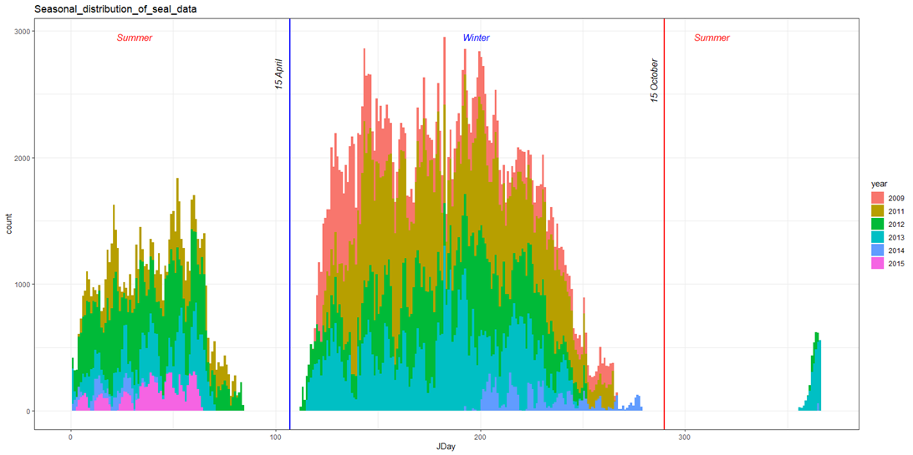

Figure : Seasonal distribution of temperature profiles collected from diving seals from winter 2009 to the first summer months of 2015. The blue vertical line represents the date 1st day of 'winter moths', while the red vertical line represents the first date of ‘summer months’ as defined in this thesis.

### Environmental variability

Temporal and spatial changes in water column structure.

Temporal and spatial variability of submesoscale ocean fronts

Some (n=) profiles experience temperature inversions because of the influence of salinity. Temperature inversions are common within and near the boundaries of the ACC (Dong *et al.*, 2008).

### Foraging response to environmental variability? Horizontal and vertical area restricted search

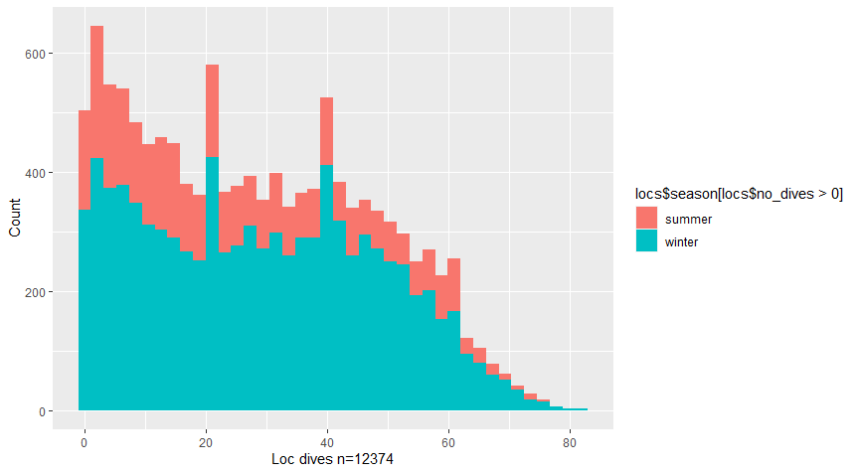

Seasonal differences in distribution of the no. of dives per location excluding locations where no dives are present.

Map from 2009-2015 of mean_Temp (expect an decrease with increasing latitude), Nt (Expect higher overall Nt on West due to topographic influence), vARS,(still to map proportion of divetype 2), Thermocline presence. For summer and winter separately.

## Discussion

**NB!!! Read Perissinotto 2000.**

I am assuming submesoscale fronts are quasi-stationary when the seal is crossing them - so that we can see this in the data. Therefore, what is the timeframe of these fronts and will I be able to find these fronts

Freshwater influx from island run-off may shoal the mixed layer (Perissinotto, Lutjeharms and Van Ballegooyen, 2000).

Our results demonstrate evidence of

## Conclusion

## Acknowledgements

## Supporting information

# Chapter 4: General conclusion

.

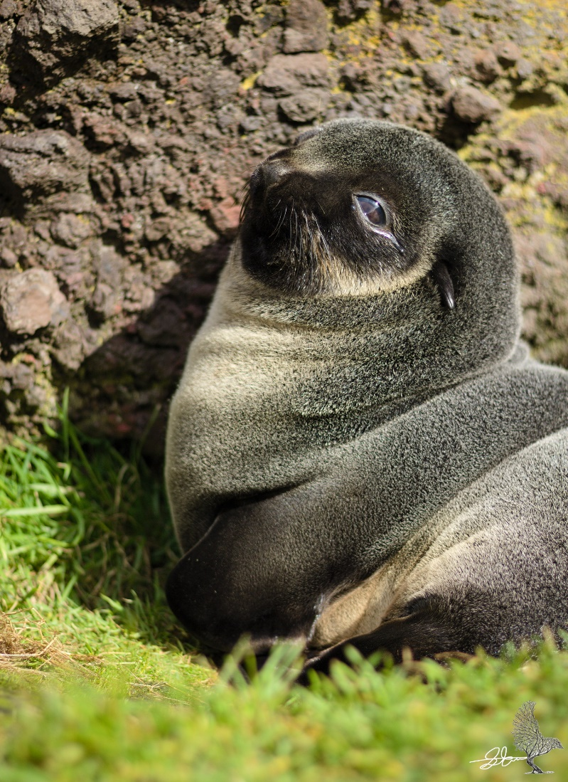15 Subantarctic fur seal sits in a rare sunny spot near Marion Island base

### Foraging and dive strategies

The scaling problem:

Because marine environmental variability and associated ocean productivity is a function of scale (Stevick *et al.*, 2002), caution needs to be taken when assuming confined foraging scales, both spatial and temporal, of mobile marine predators in telemetry studies (Pirotta *et al.*, 2014; Cumming, Henry and Reynolds, 2017). Furthermore, Bailleul *et al.*, 2008 illustrated that it is essential to include the vertical dimension when identifying the spatial scale of foraging areas of diving animals. Emphasis on scale in the analysis of foraging behavior (Arthur et al 2016) allows for effective management and conservation (Pirotta *et al.*, 2014). According to previous studies () as well as supporting evidence found in this study, patterns of foraging behavior in Subantarctic fur seals cover a range of different spatial and temporal scales. Because we cannot ask the seals directly, determining the scale of decisions that drive these behaviours is even more challenging. Like in this study, scientists use alternative variables via statistical methods (such as a broken stick model) to infer foraging which can then be used as the response variable in models. More studies need to be developed to not only fill the gaps in scale (Pirotta *et al.*, 2014) e.g., investigate the influence of submesoscales on SAFS foraging, but also to compare influences across all possible scales and investigate possible hierarchical structures of foraging ecology (Fauchald, Erikstad and Skarsfjord, 2000; Fritz, Said and Weimerskirch, 2003). This is vital for understanding seal movements and how the present climate change crisis (climate study evidence) may affect future SAFS population trends (Mia pups).

Benefits outweigh the cons:

While data logging instruments provide invaluable information about marine mammals and their environment, the potential impact of these devices cannot be discounted, and must be considered when designing ethical research programs. The consequences of instrumentation not only include short-term changes in behavior and energetics, but also potential critical biases in data sets and long-term impacts on life history traits (Rosen, Gerlinsky and Trites, 2018). results may not be representative of the natural (non-instrumented) population. But for the purposes of answering our questions, the benefits of telemetry do outweigh the cons, especially when such a small sample of the population is being studied this way.

### What can animal-borne data loggers tell us about the Marion ecosystem?

In accordance with other studies, we have found evidence for a topographic influence on downstream submesoscale variability in summer when mixed layer depths are generally shallower (Objective analysis and other studies). Despite diving deeper in winter, SAFS remain within the mixed layer preventing calculation of mixed layer depths and further analysis of west vs east comparisons in winter. During summer (West vs East). Although this puts the surrounding seasonal ocean conditions to the west and east of Marion into context, SAFS do not change their diving behavior in relation to changes in ocean variability according to these scales. After investigating direct responses of diving behavior to immediate ocean conditions, seals are further uninfluenced. These results indicate that small-scale (divewise) separation of diving behavior is not impacted by bottom-up processes. Instead, diving behavior may: be influenced by alternative drivers not related to physical ocean properties e.g. competition; be influenced by features that occur at alternative scales that were not investigated in this study e.g. submesoscale ocean features like filaments/fronts; be driven by broader decision making e.g. responding at bout or foraging trip scales. Akin to this, Wege *et al.*, 2019 has shown evidence for the lack of environmental factor influence on colony foraging areas.

Modern oceanographic methods allowing inferences of general water column structure, simultaneously providing evidence for larger potentially associated ocean features and trends, allowing the generation of a broader understanding of environmental context in which these seals forage.

### Environmental change and management

This study provides important insight into the ecology of the fur seals at Marion island. Moreover, this study could potentially serve as a pilot study for the foraging behaviour of alternative top marine predatore in this region, such as penguins species. The description/classification of marine habitats usually allows for the identification of important pelagic conservation areas (Campagna *et al.* 2007). We propose that the classification of important marine zones using seal-borne data loggers can also aid in understanding the habitat use of seal predators.

### Future work

Many studies on foraging behaviour of marine top predators typically use data that only reflects the conditions that individuals experience in pursuit of food (Lowther *et al.* 2015). Once the predator is satisfied or had to abort the dive to return to the surface, the information collected by the sensor will cease. The sensor information becomes limited to the immediate surroundings experienced by the individual. To really identify environmental thresholds or gradients that dictate the limits of animal movement, one must place its behaviour in a broader context (Lowther *et al.* 2015). Therefore, future studies should include physical oceanographic CTD data from alternative sources could be used to create an environmental context for the fine scale assessment of foraging behaviour of foraging seals in the waters close to the subantarctic islands. No such study has been carried out for predator species around the Prince Edward Islands to date. To really understand the pup population trends on Marion Island better, the fine scale diving behaviour of both sympatric fur seal species at Marion need to be investigated. Due to time constraints, this MSc only focussed on SAFS and not AFS.

Future work should include the influence of maternal traits such as age and mass on diving behavior (McDonald *et al.*, 2009)

### Synthesis

Telemetry has successfully been used at Marion Island to investigate subantarctic fur seal diving behaviour in relation to ocean stability and provide evidence for enhanced submesoscale variability downstream of the ACC.

# REFERENCES

Arce, F. *et al.* (2019) ‘A quantitative, hierarchical approach for detecting drift dives and tracking buoyancy changes in southern elephant seals’, *Scientific Reports*, 9(1), pp. 1–13. doi: 10.1038/s41598-019-44970-1.

Arnould, J. P. Y., Boyd, I. L. and Speakman, J. R. (1996) ‘The relationship between foraging behaviour and energy expenditure in Antarctic fur seals’, *Journal of Zoology*, 239(4), pp. 769–782. doi: 10.1111/j.1469-7998.1996.tb05477.x.

Arthur, B. *et al.* (2016) ‘South for the winter ? Within-dive foraging effort reveals the trade-offs between divergent foraging strategies in a free-ranging predator’, pp. 1623–1637. doi: 10.1111/1365-2435.12636.

Bailleul, F. *et al.* (2008) ‘Assessment of scale-dependent foraging behaviour in southern elephant seals incorporating the vertical dimension: a development of the First Passage Time method’, *Journal of Animal Ecology*, 77(5), pp. 948–957. doi: 10.1111/j.1365-2656.2008.01407.x.

Bates, D. *et al.* (2015) ‘Fitting linear mixed-effects models using lme4’, *Journal of Statistical Software*, 67(1). doi: 10.18637/jss.v067.i01.

Beauplet, G. *et al.* (2004) ‘Foraging ecology of subantarctic fur seals Arctocephalus tropicalis breeding on Amsterdam Island : seasonal changes in relation to maternal characteristics and pup growth’, 273, pp. 211–225.

Bester, M. N. *et al.* (2011) ‘The Marine Mammal Programme at the Prince Edward Islands: 38 years of research’, *African Journal of Marine Science*, 33(3), pp. 511–521. doi: 10.2989/1814232X.2011.637356.

Bester, M. N. *et al.* (2012) ‘The Marine Mammal Programme at the Prince Edward Islands : 38 years of research The Marine Mammal Programme at the Prince Edward Islands : 38 years of’, 2338. doi: 10.2989/1814232X.2011.637356.

Bestley, S. *et al.* (2015) ‘Taking animal tracking to new depths: Synthesizing horizontal - vertical movement relationships for four marine predators’, *Ecology*, 96(2), pp. 417–427. doi: 10.1890/14-0469.1.

Bestley, S. *et al.* (2020) ‘Marine Ecosystem Assessment for the Southern Ocean: Birds and Marine Mammals in a Changing Climate’, *Frontiers in Ecology and Evolution*, 8(November). doi: 10.3389/fevo.2020.566936.

Biuw, M. *et al.* (2007) ‘Variations in behavior and condition of a Southern Ocean top predator in relation to in situ oceanographic conditions’, 104(34), pp. 13705–13710.

Boden, B. P. (1988) ‘Observations of the island mass effect in the Prince Edward archipelago’, *Polar Biology*, 9(1), pp. 61–68. doi: 10.1007/BF00441765.

Bost, C. *et al.* (2002) ‘Feeding of diving predators and diel vertical migration of prey: King penguin diet versus trawl sampling at Kerguelen Islands’, *Marine Ecology Progress Series*, 227, pp. 51–61. doi: 10.3354/meps227051.

Boyd, I. L. and Arnbom, T. (1991) ‘Diving behaviour in relation to water temperature in the southern elephant seal: foraging implications’, *Polar Biology*, 11(4), pp. 259–266. doi: 10.1007/BF00238460.

de Boyer Montégut, C. *et al.* (2004) ‘Mixed layer depth over the global ocean: An examination of profile data and a profile-based climatology’, *Journal of Geophysical Research C: Oceans*, 109(12), pp. 1–20. doi: 10.1029/2004JC002378.

De Bruyn, P. J. N. *et al.* (2009) ‘Bathymetry and frontal system interactions influence seasonal foraging movements of lactating subantarctic fur seals from Marion Island’, *Marine Ecology Progress Series*, 394, pp. 263–276. doi: 10.3354/meps08292.

Burns, J. M. *et al.* (2008) ‘Fine-scale habitat selection of crabeater seals as determined by diving behavior’. doi: 10.1016/j.dsr2.2007.11.012.

Costa, D. P. *et al.* (2010) ‘Accuracy of ARGOS locations of pinnipeds at-sea estimated using fastloc GPS’, *PLoS ONE*, 5(1). doi: 10.1371/journal.pone.0008677.

Croxall, J. P. *et al.* (1985) ‘Fur Seal Diving Behaviour in Relation to Vertical Distribution of Krill’, *The Journal of Animal Ecology*, 54(1), p. 1. doi: 10.2307/4616.

Croxall, J. P. and Gentry, R. L. (1987) ‘Status, biology and ecology of fur seals’, *Proc. of an Int. Symp. & Workshop, Cambridge, England, 23-27 April 1984*, (April 1984), pp. 212 pp.; bibliogr.

Cumming, G. S., Henry, D. A. W. and Reynolds, C. (2017) ‘A framework for testing assumptions about foraging scales, body mass, and niche separation using telemetry data’, *Ecology and Evolution*, 7(14), pp. 5276–5284. doi: 10.1002/ece3.3078.

Dong, S. *et al.* (2008) ‘Southern Ocean mixed-layer depth from Argo float profiles’, *Journal of Geophysical Research*, 113(C6), p. C06013. doi: 10.1029/2006JC004051.

Dragon, A. *et al.* (2012) ‘Horizontal and vertical movements as predictors of foraging success in a marine predator’, *Marine Ecology Progress Series*, 447, pp. 243–257. doi: 10.3354/meps09498.

Fauchald, P., Erikstad, K. E. and Skarsfjord, H. (2000) ‘Scale-dependent predator-prey interactions: The hierarchical spatial distribution of seabirds and prey’, *Ecology*, 81(3), pp. 773–783. doi: 10.1890/0012-9658(2000)081[0773:SDPPIT]2.0.CO;2.

Fedak, M. A., Lovell, P. and Grant, S. M. (2001) ‘Two approaches to compressing and interpreting time-depth information as collected by time-depth recorders and satellite-linked data recorders’, *Marine Mammal Science*, 17(1), pp. 94–110. doi: 10.1111/j.1748-7692.2001.tb00982.x.

Field, I. C. *et al.* (2012) ‘Refining instrument attachment on phocid seals’, *Marine Mammal Science*, 28(3), pp. 1–9. doi: 10.1111/j.1748-7692.2011.00519.x.

Fritz, H., Said, S. and Weimerskirch, H. (2003) ‘Scale-dependent hierarchical adjustments of movement patterns in a long-range foraging seabird’, *Proceedings of the Royal Society B: Biological Sciences*, 270(1520), pp. 1143–1148. doi: 10.1098/rspb.2003.2350.

Froneman, P. W. *et al.* (1999) ‘Plankton community structure in the physical environment surrounding the Prince Edward Islands (Southern Ocean)’, *Polar Biology*, 22(3), pp. 145–155. doi: 10.1007/s003000050404.

Georges, A. J. *et al.* (2018) ‘Subantarctic fur seals in relation to sea-surface Foraging habitat an temperatures at Amsterdam Island’, 196, pp. 291–304.

Georges, J. Y., Tremblay, Y. and Guinet, C. (2000) ‘Seasonal diving behaviour in lactating subantarctic fur seals on Amsterdam Island’, *Polar Biology*, 23(1), pp. 59–69. doi: 10.1007/s003000050008.

Good, S. A., Martin, M. J. and Rayner, N. A. (2013) ‘EN4: Quality controlled ocean temperature and salinity profiles and monthly objective analyses with uncertainty estimates’, *Journal of Geophysical Research: Oceans*, 118(12), pp. 6704–6716. doi: 10.1002/2013JC009067.

Gouretski, V. and Reseghetti, F. (2010) ‘On depth and temperature biases in bathythermograph data: Development of a new correction scheme based on analysis of a global ocean database’, *Deep-Sea Research Part I: Oceanographic Research Papers*. Elsevier, 57(6), pp. 812–833. doi: 10.1016/j.dsr.2010.03.011.

Harcourt, R. *et al.* (2019) ‘Animal-borne telemetry: An integral component of the ocean observing toolkit’, *Frontiers in Marine Science*, 6(JUN). doi: 10.3389/fmars.2019.00326.

Harrison, X. A. *et al.* (2018) ‘A brief introduction to mixed effects modelling and multi-model inference in ecology’, *PeerJ*, 2018(5), p. e4794. doi: 10.7717/peerj.4794.

Heerah, K. *et al.* (2014) ‘A new method to quantify within dive foraging behaviour in marine predators’, *PLoS ONE*. Edited by A. Fahlman, 9(6), p. e99329. doi: 10.1371/journal.pone.0099329.

Heerah, K. *et al.* (2015) ‘From high ‑ resolution to low ‑ resolution dive datasets : a new index to quantify the foraging effort of marine predators’, *Animal Biotelemetry*. BioMed Central, pp. 1–12. doi: 10.1186/s40317-015-0074-3.

Heerah, K. *et al.* (2019) ‘Validation of dive foraging indices using archived and transmitted acceleration data: The case of the weddell seal’, *Frontiers in Ecology and Evolution*, 7(FEB), pp. 1–15. doi: 10.3389/fevo.2019.00030.

Hofmeyr, G. J. G. *et al.* (2006) ‘Population changes in Subantarctic and Antarctic fur seals at Marion Island’, *African Journal of Wildlife Research*, 36(1), pp. 55–68.

Hooker, S. K. *et al.* (2002) ‘Monitoring the prey-field of marine predators: Combining digital imaging with datalogging tags’, *Marine Mammal Science*, 18(3), pp. 680–697. doi: 10.1111/j.1748-7692.2002.tb01066.x.

Horning, M. *et al.* (2019) ‘Best practice recommendations for the use of external telemetry devices on pinnipeds’, *Animal Biotelemetry*. doi: 10.1186/s40317-019-0182-6.

Huang, P. Q., Lu, Y. Z. and Zhou, S. Q. (2018) ‘An objective method for determining ocean mixed layer depth with applications to WOCE data’, *Journal of Atmospheric and Oceanic Technology*, 35(3), pp. 441–458. doi: 10.1175/JTECH-D-17-0104.1.

IOC, SCOR and IAPSO (2010) ‘The international thermodynamic equation of seawater – 2010: Calculation and use of thermodynamic properties’, *Intergovernmental Oceanographic Commission, Manuals and Guides No. 56*, (June), p. 196.

Jones, K. A. *et al.* (2020) ‘Intra-specific Niche Partitioning in Antarctic Fur Seals, Arctocephalus gazella’, *Scientific Reports*, 10(1), pp. 1–15. doi: 10.1038/s41598-020-59992-3.

Kingdom, U. and Africa, S. (2011) ‘Refining instrument attachment on phocid seals’, pp. 1–9. doi: 10.1111/j.1748-7692.2011.00519.x.

Kirkman, S. P. *et al.* (2016) ‘Foraging behavior of subantarctic fur seals supports efficiency of a marine reserve’s design’, *PLoS ONE*, 11(5), pp. 1–19. doi: 10.1371/journal.pone.0152370.

Kirkman, S. P. *et al.* (2019) ‘Dive behaviour and foraging effort of female Cape fur seals Arctocephalus pusillus pusillus’, *Royal Society Open Science*, 6(10). doi: 10.1098/rsos.191369.

Klages, N. T. W. and Bester, M. N. (1998) ‘Fish prey of fur seals Arctocephalus spp. at subantarctic Marion Island’, *Marine Biology*, 131(3), pp. 559–566. doi: 10.1007/s002270050348.

Kodinariya, T. M. and Makwana, P. R. (2013) ‘Review on determining number of Cluster in K-Means Clustering’, *International Journal of Advance Research in Computer Science and Management Studies*, 1(6), pp. 2321–7782.

Koubbi, P. *et al.* (2011) ‘Ecoregionalization of myctophid fish in the Indian sector of the Southern Ocean: Results from generalized dissimilarity models’, *Deep-Sea Research Part II: Topical Studies in Oceanography*. Elsevier, 58(1–2), pp. 170–180. doi: 10.1016/j.dsr2.2010.09.007.

Leathwick, J. R., Elith, J. and Hastie, T. (2006) ‘Comparative performance of generalized additive models and multivariate adaptive regression splines for statistical modelling of species distributions’, *Ecological Modelling*, 199(2), pp. 188–196. doi: 10.1016/j.ecolmodel.2006.05.022.

Lee, W. Y. *et al.* (2015) ‘Diel diving behavior of breeding gentoo penguins on King George Island in Antarctica’, *Animal Cells and Systems*. Taylor & Francis, 19(4), pp. 274–281. doi: 10.1080/19768354.2015.1074107.

Lowther, A. D., Lydersen, C. and Kovacs, K. M. (2015) ‘A sum greater than its parts: Merging multi-predator tracking studies to increase ecological understanding’, *Ecosphere*, 6(12), pp. 1–13. doi: 10.1890/ES15-00293.1.

Luque, S., Arnould, J. and Guinet, C. (2008) ‘Temporal structure of diving behaviour in sympatric Antarctic and subantarctic fur seals’, *Marine Ecology Progress Series*, 372, pp. 277–287. doi: 10.3354/meps07689.

McDonald, B. I. *et al.* (2009) ‘Effects of maternal traits and individual behavior on the foraging strategies and provisioning rates of an income breeder, the Antarctic fur seal’, *Marine Ecology Progress Series*, 394, pp. 277–288. doi: 10.3354/meps08308.

McIntyre, T. (2014) ‘Trends in tagging of marine mammals: a review of marine mammal biologging studies’, *African Journal of Marine Science*, 36(4), pp. 409–422. doi: 10.2989/1814232X.2014.976655.

Mcmahon, C. R. *et al.* (2005) ‘Animal-borne sensors successfully capture the real-time thermal properties of ocean basins’, *Limnology and Oceanography: Methods*, 3(9), pp. 392–398. doi: 10.4319/lom.2005.3.392.

Mike, F. (2004) ‘Marine animals as platforms for oceanographic sampling: a “win/win” situation for biology and operational oceanography’, *Memoirs of National Institute of Polar Research. Special issue*, 58, pp. 133–147.

Moore, J. K. and Abbott, M. R. (2000) ‘Phytoplankton chlorophyll distributions and primary production in the Southern Ocean’, *Journal of Geophysical Research: Oceans*, 105(C12), pp. 28709–28722. doi: 10.1029/1999jc000043.

Patterson, T. A. *et al.* (2010) ‘Using GPS data to evaluate the accuracy of state–space methods for correction of Argos satellite telemetry error’, *Ecology*, 91(1), pp. 273–285. doi: 10.1890/08-1480.1.

Patterson, T. A. *et al.* (2016) ‘Foraging distribution overlap and marine reserve usage amongst sub-Antarctic predators inferred from a multi-species satellite tagging experiment’, *Ecological Indicators*. Elsevier Ltd, 70, pp. 531–544. doi: 10.1016/j.ecolind.2016.05.049.

Pellichero, V. *et al.* (2017) ‘The ocean mixed layer under Southern Ocean sea-ice: Seasonal cycle and forcing’, *Journal of Geophysical Research: Oceans*, 122(2), pp. 1608–1633. doi: 10.1002/2016JC011970.

Perissinotto, R., Lutjeharms, J. R. E. and Van Ballegooyen, R. C. (2000) ‘Biological-physical interactions and pelagic productivity at the Prince Edward Islands, Southern Ocean’, *Journal of Marine Systems*, 24(3–4), pp. 327–341. doi: 10.1016/S0924-7963(99)00093-7.

Phillips, E. M. and Harvey, J. T. (2009) ‘A captive feeding study with the Pacific harbor seal (Phoca vitulina richardii): Implications for scat analysis’, *Marine Mammal Science*, 25(2), pp. 373–391. doi: 10.1111/j.1748-7692.2008.00265.x.

Photopoulou, T. *et al.* (2015) ‘Efficient abstracting of dive profiles using a broken-stick model’, *Methods in Ecology and Evolution*, 6(3), pp. 278–288. doi: 10.1111/2041-210X.12328.

Photopoulou, T. *et al.* (2020) ‘Sex-specific variation in the use of vertical habitat by a resident Antarctic top predator’, *Proceedings of the Royal Society B: Biological Sciences*, 287(1937), p. 20201447. doi: 10.1098/rspb.2020.1447.

Pinaud, D. and Weimerskirch, H. (2005) ‘Scale-dependent habitat use in a long-ranging central place predator’, *Journal of Animal Ecology*, 74(5), pp. 852–863. doi: 10.1111/j.1365-2656.2005.00984.x.

Pirotta, E. *et al.* (2014) ‘Scale-dependent foraging ecology of a marine top predator modelled using passive acoustic data’, *Functional Ecology*, 28(1), pp. 206–217. doi: 10.1111/1365-2435.12146.

Du Plessis, M. *et al.* (2019) ‘Southern Ocean seasonal restratification delayed by submesoscale wind-front interactions’, *Journal of Physical Oceanography*, 49(4), pp. 1035–1053. doi: 10.1175/JPO-D-18-0136.1.

Quinn, G. P. and Keough, M. J. (2002) ‘Introduction’, in *Experimental Design and Data Analysis for Biologists*. Cambridge University Press, pp. 1–13. doi: 10.1017/CBO9780511806384.002.

R Core Team (2020) *A Language and Environment for Statistical Computing*, *R Foundation for Statistical Computing*. R Foundation for Statistical Computing, Vienna, Austria. Available at: http://www.r-project.org.

Reisinger, R. R., Raymond, B., *et al.* (2018) ‘Habitat modelling of tracking data from multiple marine predators identifies important areas in the Southern Indian Ocean’, *Diversity and Distributions*. Edited by D. Schoeman, 24(4), pp. 535–550. doi: 10.1111/ddi.12702.

Reisinger, R. R., Landman, M., *et al.* (2018) ‘Overlap and temporal variation in the diets of sympatric Antarctic and Subantarctic fur seals ( Arctocephalus spp.) at Marion Island, Prince Edward Islands’, *Polar Research*. Routledge, 37(1), p. 1451142. doi: 10.1080/17518369.2018.1451142.

Roncon, G. *et al.* (2018) ‘View from below: Inferring behavior and physiology of Southern Ocean marine predators from dive telemetry’, *Frontiers in Marine Science*, 5(DEC), pp. 1–23. doi: 10.3389/fmars.2018.00464.

Rosen, D. A. S., Gerlinsky, C. G. and Trites, A. W. (2018) ‘Telemetry tags increase the costs of swimming in northern fur seals, Callorhinus ursinus’, *Marine Mammal Science*, 34(2), pp. 385–402. doi: 10.1111/mms.12460.

Rosso, I. *et al.* (2015) ‘Topographic influence on submesoscale dynamics in the Southern Ocean’, *Geophysical Research Letters*, 42(4), pp. 1139–1147. doi: 10.1002/2014GL062720.

Rousseeuw, P. J. (1987) ‘Silhouettes: A graphical aid to the interpretation and validation of cluster analysis’, *Journal of Computational and Applied Mathematics*, 20(C), pp. 53–65. doi: 10.1016/0377-0427(87)90125-7.

Sallée, J. B. *et al.* (2010) ‘Southern ocean thermocline ventilation’, *Journal of Physical Oceanography*, 40(3), pp. 509–529. doi: 10.1175/2009JPO4291.1.

Schielzeth, H. and Forstmeier, W. (2009) ‘Conclusions beyond support: Overconfident estimates in mixed models’, *Behavioral Ecology*, 20(2), pp. 416–420. doi: 10.1093/beheco/arn145.

Smetacek, V. and Nicol, S. (2005) ‘Polar ocean ecosystems in a changing world’, 437(September). doi: 10.1038/nature04161.

Stearns, S. C. (2000) ‘Life history evolution: successes, limitations, and prospects’, *Naturwissenschaften*, 87(11), pp. 476–486. doi: 10.1007/s001140050763.

Treasure, A. *et al.* (2017) ‘Marine Mammals Exploring the Oceans Pole to Pole: A Review of the MEOP Consortium’, *Oceanography*, 30(2), pp. 132–138. doi: 10.5670/oceanog.2017.234.

Viviant, M. *et al.* (2016) ‘Bottom time does not always predict prey encounter rate in Antarctic fur seals’, *Functional Ecology*. Edited by D. Costa, 30(11), pp. 1834–1844. doi: 10.1111/1365-2435.12675.

Wege, M. (2013) *Maternal foraging behaviour of Subantarctic fur seals from Marion Island*, *MSc. Thesis*.

Wege, M *et al.* (2016) ‘Cross-seasonal foraging site fidelity of subantarctic fur seals: Implications for marine conservation areas’, *Marine Ecology Progress Series*, 554, pp. 225–239. doi: 10.3354/meps11798.

Wege, Mia *et al.* (2016) ‘Trend changes in sympatric Subantarctic and Antarctic fur seal pup populations at Marion Island, Southern Ocean’, *Marine Mammal Science*, 32(3), pp. 960–982. doi: 10.1111/mms.12306.

Wege, M (2017) *Population trend and foraging ecology of Antarctic and Subantarctic fur seals at Marion Island*.

Wege, Mia (2017) *Population trend and foraging ecology of Antarctic and Subantarctic fur seals at Marion Island*.

Wege, M. *et al.* (2019) ‘Preferred, small-scale foraging areas of two Southern Ocean fur seal species are not determined by habitat characteristics’, *BMC Ecology*. BioMed Central, 19(1), pp. 1–14. doi: 10.1186/s12898-019-0252-x.

Wei, C. P., Lee, Y. H. and Hsu, C. M. (2000) ‘Empirical comparison of fast clustering algorithms for large data sets’, in *Proceedings of the Annual Hawaii International Conference on System Sciences*, pp. 1–10.

Weimerskirch, H. *et al.* (2007) ‘Does prey capture induce area-restricted search? A fine-scale study using GPS in a marine predator, the wandering albatross’, *American Naturalist*, 170(5), pp. 734–743. doi: 10.1086/522059.

Ydenberg, R. C. and Clark, C. W. (1989) ‘Aerobiosis and anaerobiosis during diving by western grebes: An optimal foraging approach’, *Journal of Theoretical Biology*, 139(4), pp. 437–447. doi: 10.1016/S0022-5193(89)80064-5.

Zuur, A. F., Ieno, E. N. and Elphick, C. S. (2010) ‘A protocol for data exploration to avoid common statistical problems’, *Methods in Ecology and Evolution*, 1(1), pp. 3–14. doi: 10.1111/j.2041-210X.2009.00001.x.

**Manual citations**

Goldsworthy, S.D., Hindell, M.A. and Crowley, H.M. (1997) Diet and diving behaviour of sympatric fur seals Arctocephalus gazella and A. tropicalis at Macquarie Island. In *Marine mammal research in the Southern Hemisphere* (Vol. 1, pp. 151-163).

Kaufman, L. and Rousseeuw, P.J. (1990) Partitioning around medoids (program pam). *Finding groups in data: an introduction to cluster analysis*, *344*, pp.68-125.

Rousseeuw, P.J. and Kaufman, L. (1990) Finding groups in data. *Hoboken: Wiley Online Library*, *1*.

Stephens, D.W, and Krebs, J.R. (1986) Foraging Theory. Princeton: Princeton University Press.

Stevick, P.T., McConnell, B.J. and Hammond, P.S. (2002) Patterns of movement. *Marine mammal biology: An evolutionary approach*, pp.185-216.

Underhill, L. and Bradfield, D. (1996) *Introstat*. Juta and Company Ltd.

Wege, M (2017) Population trend and foraging ecology of Antarctic and Subantarctic fur seals at Marion Island. PhD Thesis, University of Pretoria.

Abrams, R.W. and Lutjeharms, J.R.E., (1986). Relationships between seabirds and mesoscale hydrographic features in the Agulhas current retroflection region. *Acta XIX Congressus Internationalis Ornithologici*, *1*, pp.991-996.

Abrams, R.W., (1983). Distribution of seabirds in the African sector of FIBEX. *South African Journal of Antarctic Research*, *13*, pp.24-28.

Ansorge, I.J. and Lutjeharms, J.R., (2005). Direct observations of eddy turbulence at a ridge in the Southern Ocean. *Geophysical Research Letters*, *32*(14).

Ansorge, I.J. and Lutjeharms, J.R.E., (2000). Twenty-five years of physical oceanographic research at the Prince Edward Islands. *South African Journal of Science*, *96*.

Ansorge, I.J. and Lutjeharms, J.R.E., (2003). Eddies originating at the South-west Indian ridge. *Journal of Marine Systems*, *39*(1-2), pp.1-18.

Ansorge, I.J., Durgadoo, J.V. and Treasure, A.M., (2014). Sentinels to climate change. The need for monitoring at South Africa's Subantarctic laboratory. *South African Journal of Science*, *110*(1-2), pp.1-4.

Ansorge, I.J., Froneman, P.W., Pakhomov, E.A., Lutjeharms, J.R.E., Perissinotto, R. and Van Ballegooyen, R.C., (1999). Physical-biological coupling in the waters surrounding the Prince Edward Islands (Southern Ocean). *Polar Biology*, *21*(3), pp.135-145.

Arce, F. *et al.* (2019) ‘A quantitative, hierarchical approach for detecting drift dives and tracking buoyancy changes in southern elephant seals’, *Scientific Reports*, 9(1), pp. 1–13. doi: 10.1038/s41598-019-44970-1.

Arthur, B., Hindell, M., Bester, M.N., Oosthuizen, W.C., Wege, M. and Lea, M.A., (2016). South for the winter? Within‐dive foraging effort reveals the trade‐offs between divergent foraging strategies in a free‐ranging predator. *Functional Ecology*, *30*(10), pp.1623-1637.

Asdar, S., (2018). Climate Change Impact on Ecosystems of Prince Edward Islands: Role of Oceanic Mesoscale Processes. PhD thesis, University of Cape Town.

Bakun, A., (2006). Fronts and eddies as key structures in the habitat of marine fish larvae: opportunity, adaptive response and competitive advantage. *Scientia Marina*, *70*(S2), pp.105-122.

Balcerak, E., (2014). Seal‐borne sensors are valuable for studies of Southern Ocean conditions. *Eos, Transactions American Geophysical Union*, *95*(6), pp.60-60.

Barange, M., Pakhomov, E.A., Perissinotto, R., Froneman, P.W., Verheye, H.M., Taunton-Clark, J. and Lucas, M.I., (1998). Pelagic community structure of the subtropical convergence region south of Africa and in the mid-Atlantic Ocean. *Deep Sea Research Part I: Oceanographic Research Papers*, *45*(10), pp.1663-1687.

Bester, M.N., (1988). Chemical restraint of Antarctic fur seals and southern elephant seals. *South African Journal of Wildlife Research-24-month delayed open-access*, *18*(2), pp.57-60.

Bester, M.N., De Bruyn, P.J.N., Oosthuizen, W.C., Tosh, C.A., McIntyre, T., Reisinger, R.R., Postma, M., Van der Merwe, D.S. and Wege, M., (2011). The marine mammal programme at the Prince Edward islands: 38 years of research. *African Journal of Marine Science*, *33*(3), pp.511-521.

Biuw, M., McConnell, B., Bradshaw, C.J., Burton, H. and Fedak, M., (2003). Blubber and buoyancy: monitoring the body condition of free-ranging seals using simple dive characteristics. *Journal of Experimental Biology*, *206*(19), pp.3405-3423.

Biuw, M. *et al.* (2007) ‘Variations in behavior and condition of a Southern Ocean top predator in relation to in situ oceanographic conditions’, *Proceedings of the National Academy of Sciences of the United States of America*, 104(34), pp. 13705–13710. doi: 10.1073/pnas.0701121104.

Boehlert, G.W., Costa, D.P., Crocker, D.E., Green, P., O'Brien, T., Levitus, S. and Le Boeuf, B.J., (2001). Autonomous pinniped environmental samplers: using instrumented animals as oceanographic data collectors. *Journal of atmospheric and oceanic technology*, *18*(11), pp.1882-1893.

Boehme, L., Lovell, P., Biuw, M., Roquet, F., Nicholson, J., Thorpe, S.E., Meredith, M.P. and Fedak, M., (2009). Animal-borne CTD-Satellite Relay Data Loggers for real-time oceanographic data collection. *Ocean Science*.

Boelhouwers, J.C., Meiklejohn, I.K., Holness, S.D., Hedding, D.W., (2008). Chapter 4: Geology, geomorphology and climate change. *The Prince Edward Islands. Land-Sea Interactions in a Changing Ecosystem. African Sun Media, Stellenbosch*, pp.65-96.

Bost, C.A., Cotté, C., Bailleul, F., Cherel, Y., Charrassin, J.B., Guinet, C., Ainley, D.G. and Weimerskirch, H., (2009). The importance of oceanographic fronts to marine birds and mammals of the southern oceans. *Journal of Marine Systems*, *78*(3), pp.363-376.

Campagna, C., Sanderson, E.W., Coppolillo, P.B., Falabella, V., Piola, A.R., Strindberg, S. and Croxall, J.P., (2007). A species approach to marine ecosystem conservation. *Aquatic Conservation: Marine and Freshwater Ecosystems*, *17*(S1).

Capet, X.J., Marchesiello, P., Mcwilliams, J.C., (2004). Upwelling response to coastal wind profiles.

Charrassin, J.B., Hindell, M., Rintoul, S.R., Roquet, F., Sokolov, S., Biuw, M., Costa, D., Boehme, L., Lovell, P., Coleman, R. and Timmermann, R., (2008). Southern Ocean frontal structure and sea-ice formation rates revealed by elephant seals. *Proceedings of the National Academy of Sciences*, *105*(33), pp.11634-11639.

Chown, S.L. and Gaston, K.J., (1999). Patterns in procellariiform diversity as a test of species-energy theory in marine systems. *Evolutionary Ecology Research*, *1*(3), pp.365-373.

Cotté, C., d’Ovidio, F., Dragon, A.C., Guinet, C. and Lévy, M., (2015). Flexible preference of southern elephant seals for distinct mesoscale features within the Antarctic Circumpolar Current. *Progress in Oceanography*, *131*, pp.46-58.

Crawford, A., (1982). *Tristan da Cunha and the roaring forties*. Charles Skilton.

Crawford, A., (1999). Of potatoes, penguins and postage stamps. *Oswestry: Anthony Nelson*.

de Boyer Montégut, C., Madec, G., Fischer, A.S., Lazar, A. and Iudicone, D., (2004). Mixed layer depth over the global ocean: An examination of profile data and a profile‐based climatology. *Journal of Geophysical Research: Oceans*, *109*(C12).

Dong, S., Sprintall, J., Gille, S.T. and Talley, L., (2008). Southern Ocean mixed‐layer depth from Argo float profiles. *Journal of Geophysical Research: Oceans*, *113*(C6).

Emery, W.J., (1977). Antarctic polar frontal zone from Australia to the Drake Passage. *Journal of Physical Oceanography*, *7*(6), pp.811-822.

Erickson, A.W., Bester, M.N., (1993). Immobilization and capture. In: Laws RM (ed) Antarctic seals: research methods and techniques. Cambridge University Press, Cambridge, pp 46–89.

Fedak, M., Lovell, P., McConnell, B. and Hunter, C., (2002). Overcoming the constraints of long range radio telemetry from animals: getting more useful data from smaller packages. *Integrative and Comparative Biology*, *42*(1), pp.3-10.

Field, I.C., Harcourt, R.G., Boehme, L., Bruyn, P.J., Charrassin, J.B., McMahon, C.R., Bester, M.N., Fedak, M.A. and Hindell, M.A., (2012). Refining instrument attachment on phocid seals. *Marine Mammal Science*, *28*(3).

Gould, J., Roemmich, D., Wijffels, S., Freeland, H., Ignaszewsky, M., Jianping, X., Pouliquen, S., Desaubies, Y., Send, U., Radhakrishnan, K. and Takeuchi, K., (2004). Argo profiling floats bring new era of *in situ* ocean observations. *Eos, Transactions American Geophysical Union*, *85*(19), pp.185-191.

Gould, W.J. and Turton, J., (2006). Argo–sounding the oceans. *Weather*, *61*(1), pp.17-21.

Griffiths, A.M., Siegfried, W.R. and Abrams, R.W., (1982). Ecological structure of a pelagic seabird community in the Southern Ocean. *Polar Biology*, *1*(1), pp.39-46.

Heerah, K., Hindell, M., Guinet, C. and Charrassin, J.B., (2014). A new method to quantify within dive foraging behaviour in marine predators. *PLoS One*, *9*(6), p.e99329.

Hofmann, E.E., (1985). The large‐scale horizontal structure of the Antarctic Circumpolar Current from FGGE drifters. *Journal of Geophysical Research: Oceans*, *90*(C4), pp.7087-7097.

Hogg, N.G., (1973). On the stratified Taylor column. *Journal of Fluid Mechanics*, *58*(3), pp.517-537.

Hooker, S.K. and Boyd, I.L., (2003). Salinity sensors on seals: use of marine predators to carry CTD data loggers. *Deep Sea Research Part I: Oceanographic Research Papers*, *50*(7), pp.927-939.

Hussey, N.E., Kessel, S.T., Aarestrup, K., Cooke, S.J., Cowley, P.D., Fisk, A.T., Harcourt, R.G., Holland, K.N., Iverson, S.J., Kocik, J.F. and Flemming, J.E.M., (2015). Aquatic animal telemetry: a panoramic window into the underwater world. *Science*, *348*(6240), p.1255642.

Jury, M.R., Kamstra, F. & Taunton-Clark, J., (1985). Diurnal wind cycles and upwelling off the northern portion of the Cape Peninsula in summer. South African Journal of Marine Science. 3(1):1-10.

Kara, A.B., Rochford, P.A. and Hurlburt, H.E., (2000). An optimal definition for ocean mixed layer depth. *Journal of Geophysical Research: Oceans*, *105*(C7), pp.16803-16821.

Kostianoy, A.G., Ginzburg, A.I., Lebedev, S.A., Frankignoulle, M. and Delille, B., (2003). Fronts and mesoscale variability in the southern Indian Ocean as inferred from the TOPEX/POSEIDON and ERS-2 altimetry data. *OCEANOLOGY C/C OF OKEANOLOGIIA*, *43*(5), pp.632-642.

Lauro, F.M., Senstius, S.J., Cullen, J., Neches, R., Jensen, R.M., Brown, M.V., Darling, A.E., Givskov, M., McDougald, D., Hoeke, R. and Ostrowski, M., (2014). The common oceanographer: crowdsourcing the collection of oceanographic data. PLoS biology, 12(9), p.e1001947.

Llido, J., Garçon, V., Lutjeharms, J.R.E. and Sudre, J., (2005). Event‐scale blooms drive enhanced primary productivity at the Subtropical Convergence. *Geophysical research letters*, *32*(15).

Lombard, A.T., Reyers, B., Schonegevel, L.Y., Cooper, J., Smith-Adao, L.B., Nel, D.C., Froneman, P.W., Ansorge, I.J., Bester, M.N., Tosh, C.A. and Strauss, T., (2007). Conserving pattern and process in the Southern Ocean: designing a marine protected area for the Prince Edward Islands. *Antarctic Science*, *19*(1), pp.39-54.

Lutjeharms, J.R.E. and Ansorge, I.J., (2008). Chapter 2: Oceanographic setting of the Prince Edward Islands. *The Prince Edward Islands. Land-Sea Interactions in a Changing Ecosystem. African Sun Media, Stellenbosch*, pp.17-38.

Lutjeharms, J.R.E. and Valentine, H.R., (1984). Southern Ocean thermal fronts south of Africa. *Deep Sea Research Part A. Oceanographic Research Papers*, *31*(12), pp.1461-1475.

Lutjeharms, J.R.E., (1985). Location of frontal systems between Africa and Antarctica: some preliminary results. *Deep Sea Research Part A. Oceanographic Research Papers*, *32*(12), pp.1499-1509.

Lutjeharms, J.R.E., Allanson, B.R. and Parker, L., (1986). Frontal zones, chlorophyll and primary production patterns in the surface waters of the Southern Ocean south of Cape Town. In *Elsevier oceanography series* (Vol. 42, pp. 105-117). Elsevier.

Lutjeharms, J.R.E., Walters, N.M. and Allanson, B.R., (1985). Oceanic frontal systems and biological enhancement. In *Antarctic nutrient cycles and food webs* (pp. 11-21). Springer, Berlin, Heidelberg.

Lydersen, C., Nøst, O.A., Kovacs, K.M. and Fedak, M.A., (2004). Temperature data from Norwegian and Russian waters of the northern Barents Sea collected by free-living ringed seals. *Journal of Marine Systems*, *46*(1), pp.99-108.

Mallett, H.K., Boehme, L., Fedak, M.A., Heywood, K.J., Stevens, D.P. and Roquet, F., (2018). Variation in the distribution and properties of Circumpolar Deep Water in the eastern Amundsen Sea, on seasonal timescales, using seal‐borne tags. *Geophysical Research Letters*.

McIntyre, T., Donaldson, A. and Bester, M.N., (2016). Spatial and temporal patterns of changes in condition of southern elephant seals. *Antarctic Science*, *28*(2), pp.81-90.

McQuaid, C.D. and Froneman, P.W., (2004). Rhodes Southern Ocean Group: scientific findings from seventeen years of biological oceanography in the South African National Antarctic Programme. *South African Journal of Science*, *100*, pp.571-577.

Moore, J.K., Abbott, M.R. and Richman, J.G., (1999a). Location and dynamics of the Antarctic Polar Front from satellite sea surface temperature data. *Journal of Geophysical Research: Oceans*, *104*(C2), pp.3059-3073.

Moore, J.K., Abbott, M.R., Richman, J.G., Smith, W.O., Cowles, T.J., Coale, K.H., Gardner, W.D. and Barber, R.T., (1999b). SeaWiFS satellite ocean color data from the Southern Ocean. *Geophysical Research Letters*, *26*(10), pp.1465-1468.

Moore, J. K. and Abbott, M. R. (2000) ‘Phytoplankton chlorophyll distributions and primary production in the Southern Ocean’, *Journal of Geophysical Research: Oceans*, 105(C12), pp. 28709–28722. doi: 10.1029/1999jc000043.

Nel, D.C., Lutjeharms, J.R.E., Pakhomov, E.A., Ansorge, I.J., Ryan, P.G. and Klages, N.T.W., (2001). Exploitation of mesoscale oceanographic features by grey-headed albatross Thalassarche chrysostoma in the southern Indian Ocean. *Marine Ecology Progress Series*, *217*, pp.15-26.

Nowlin, W.D. and Klinck, J.M., (1986). The physics of the Antarctic circumpolar current. *Reviews of Geophysics*, *24*(3), pp.469-491.

Olson, D.B., (1991). Rings in the ocean. *Annual Review of Earth and Planetary Sciences*, *19*(1), pp.283-311.

Pakhomov, E.A. and Chown, S.L., (2003). Prince Edward Islands: Southern Ocean Oasis, The. *Ocean YB*, *17*, p.348.

Pakhomov, E.A. and Froneman, P.W., (1999). The Prince Edward Islands pelagic ecosystem, south Indian Ocean: a review of achievements, 1976–1990. *Journal of Marine Systems*, *18*(4), pp.355-367.

Pakhomov, E.A. and McQuaid, C.D., (1996). Distribution of surface zooplankton and seabirds across the Southern Ocean. *Polar Biology*, *16*(4), pp.271-286.

Pakhomov, E.A., Perissinotto, R. and McQuaid, C.D., (1994). Comparative structure of the macrozooplankton/micronekton communities of the Subtropical and Antarctic Polar Fronts. *Marine Ecology Progress Series*, pp.155-169.

Perissinotto, R. and Rae, C.D., (1990). Occurrence of anticyclonic eddies on the Prince Edward Plateau (Southern Ocean): effects on phytoplankton biomass and production. *Deep Sea Research Part A. Oceanographic Research Papers*, *37*(5), pp.777-793.

Pistorius, P.A., De Bruyn, P.J.N. and Bester, M.N., (2011). Population dynamics of southern elephant seals: a synthesis of three decades of demographic research at Marion Island. *African Journal of Marine Science*, *33*(3), pp.523-534.

Rayner, N.A., Parker, D.E., Horton, E.B., Folland, C.K., Alexander, L.V., Rowell, D.P., Kent, E.C. and Kaplan, A., (2003). Global analyses of sea surface temperature, sea ice, and night marine air temperature since the late nineteenth century. *Journal of Geophysical Research: Atmospheres*, *108*(D14).

Reynolds, R.W., Folland, C.K. and Parker, D.E., (1989). Biases in satellite-derived sea-surface-temperature data. *Nature*, *341*(6244), p.728.

Rintoul, S.R., Speer, K., Sparrow, M., Meredith, M., Hofmann, E., Fahrbach, E., Summerhayes, C., Worby, A., England, M., Bellerby, R. and Speich, S., (2010). Southern Ocean Observing System (SOOS): Rationale and strategy for sustained observations of the Southern Ocean. *Proceedings of OceanObs ‘09: Sustained Ocean Observations and Information for Society*.

Robinson, I.S., (2010). Discovering the ocean from space: The unique applications of satellite oceanography. Springer Science & Business Media.

Roquet, F., Charrassin, J.B., Marchand, S., Boehme, L., Fedak, M., Reverdin, G. and Guinet, C., (2011). Delayed-mode calibration of hydrographic data obtained from animal-borne satellite relay data loggers. *Journal of Atmospheric and Oceanic Technology*, *28*(6), pp.787-801.

Roquet, F., Park, Y.H., Guinet, C., Bailleul, F. and Charrassin, J.B., (2009). Observations of the Fawn Trough Current over the Kerguelen Plateau from instrumented elephant seals. *Journal of Marine Systems*, *78*(3), pp.377-393.

Roquet, F., Wunsch, C., Forget, G., Heimbach, P., Guinet, C., Reverdin, G., Charrassin, J.B., Bailleul, F., Costa, D.P., Huckstadt, L.A. and Goetz, K.T., (2013). Estimates of the Southern Ocean general circulation improved by animal‐borne instruments. Geophysical Research Letters, 40(23), pp.6176-6180.

Ryan, P.G. and Bester, M.N., (2008). Chapter 6: Pelagic predators. *The Prince Edward Islands. Land-Sea Interactions in a Changing Ecosystem. African Sun Media, Stellenbosch*, pp.121-164.

Screen, J.A., Gillett, N.P., Stevens, D.P., Marshall, G.J. and Roscoe, H.K., (2009). The role of eddies in the Southern Ocean temperature response to the Southern Annular Mode. *Journal of Climate*, *22*(3), pp.806-818.

Smetacek, V. and Nicol, S. (2005) ‘Polar ocean ecosystems in a changing world’, *Nature*, 437(7057), pp. 362–368. doi: 10.1038/nature04161.

Smith, V.R., (2002). Climate change in the sub-Antarctic: an illustration from Marion Island. *Climatic Change*, *52*(3), pp.345-357.

Thomson, R.E. and Fine, I.V., (2003). Estimating mixed layer depth from oceanic profile data. *Journal of Atmospheric and Oceanic Technology*, *20*(2), pp.319-329.

Thums, M., Bradshaw, C.J. and Hindell, M.A., (2008). A validated approach for supervised dive classification in diving vertebrates. *Journal of Experimental Marine Biology and Ecology*, *363*(1-2), pp.75-83.

Tosh, C.A., de Bruyn, P.N., Steyn, J., Bornemann, H., van den Hoff, J., Stewart, B.S., Plötz, J. and Bester, M.N., (2015). The importance of seasonal sea surface height anomalies for foraging juvenile southern elephant seals. *Marine biology*, *162*(10), pp.2131-2140.

Tosh, C.A., Steyn, J., Bornemann, H., Van den Hoff, J., Stewart, B.S., Plötz, J. and Bester, M.N., (2012). Marine habitats of juvenile southern elephant seals from Marion Island. *Aquatic Biology*, *17*(1), pp.71-79.

Treasure, A., Roquet, F., Ansorge, I.J., Bester, M.N., Boehme, L., Bornemann, H., Charrassin, J.B., Chevallier, D., Costa, D.P., Fedak, M.A. and Guinet, C., (2017). Marine mammals exploring the oceans pole to pole: a review of the MEOP consortium. *Oceanography*.

Wege, M., (2017). Population trend and foraging ecology of Antarctic and Subantarctic fur seals at Marion Island. PhD Thesis, University of Pretoria.